New Mexico Highlands University
School of Social Work
First Semester-SOWK 4510/SOWK 5510
FIELD PRACTICUM ACTIVITY LOG
STUDENT NAME____________________________________________________________________
PRIMARY CONTACT NUMBER ________/________/_____ E-MAIL ___________________________

CLASSIFICATION

_____ BSW
_____ 1ST YR MSW (logs required for first semester of practicum only)
AGENCY_________________________________________________
AGENCY INSTRUCTOR _______________________CO-INSTRUCTOR _________________________
FIELD CONSULTANT________________________________
ACTIVITY LOG GUIDELINES
The major objective of the field practicum seminar and the activity log is to encourage students to utilize the nine CSWE competencies and relevant practice behaviors to critically think about the theoretical and conceptual contribution of the classroom with the field practicum. Students are required to maintain a weekly (typed) log and submit weekly or bi-weekly (depending on how often seminar meets), to the field seminar instructor throughout the entire semester. All entries and discussions of your log in the classroom setting must protect client and agency confidentiality and cannot contain identifying information. You are not required to share the activity log with your agency instructor. Logs are to be shared in the field seminar class. Save all activity logs as you will have to refer to them in your second semester of practicum and will have to submit them to field seminar instructor at the end of the second semester.

The purpose of the activity log is to encourage students to:
- Critically contemplate the ways in which the social work competencies are operationalized (put into practice) in your field practicum setting.
- Complete weekly activities/assignments focused on the building blocks of social work practice in the field setting.
- Establish an ongoing dialog with agency instructor, field consultant and field seminar instructor in order to experience the field practicum as an integrated aspect of your learning.
- Write clear and concise narratives of your weekly experiences.
- Examine personal expectations of self as learner in the field setting
- Critically integrate material from practice, human behavior, research and policy into your field experience.
- Learn to use field instruction effectively.
ACTIVITY LOG 1
(in class exercises)
Exercise 1-Reflection on the Field of Social Work and Field Practicum
Answer the following questions during class and be prepared to discuss.
- How do you see your practicum supporting you in becoming a social worker?

- How will this profession fit you and/or how will you fit into this profession?
(include positive and negative aspects)

- What strategies will you employ during your practicum that will promote/maintain good self-care?

- What strengths/contributions do you feel you can make at practicum agency?

Exercise 2-Discussion/Development of Learning Contract
Reference the learning contract template available on the Field Education SharePoint page. Please use the steps below from the FVSSW Field Policy and Procedure Manual. Write down what you would like to learn at this practicum and why you selected this site.
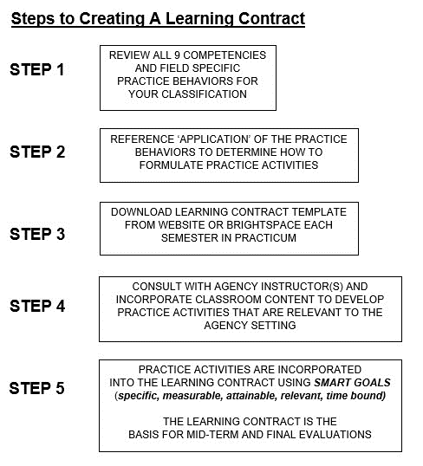

ACTIVITY LOG 2
(in class exercise)
Discussion/Development of learning contract (continued)
Reference the ideas from Log 1 regarding what you want to learn in your field practicum. Develop these ideas as illustrated below. They will become the practice activities for the learning contract. In class, you will develop five practice activities under different competencies and following the SMART goals guidelines. Below is an example:
Develop my client interviewing skills by meeting with six clients for intake process by the end of the semester.
**The importance of writing in social work: Writing clearly and concisely is a skill needed to be a competent social worker. Developing your learning contract is a way practice and demonstrate your writing skills.
The links below offer guidance and assistance on writing effectively and can be used for your other classes in addition to seminar.
- A Writing Guide for Social Work-Student Edition by Christopher D. Kilgore, University of Texas, Arlington.
- Socialwork.org-Writing Guide

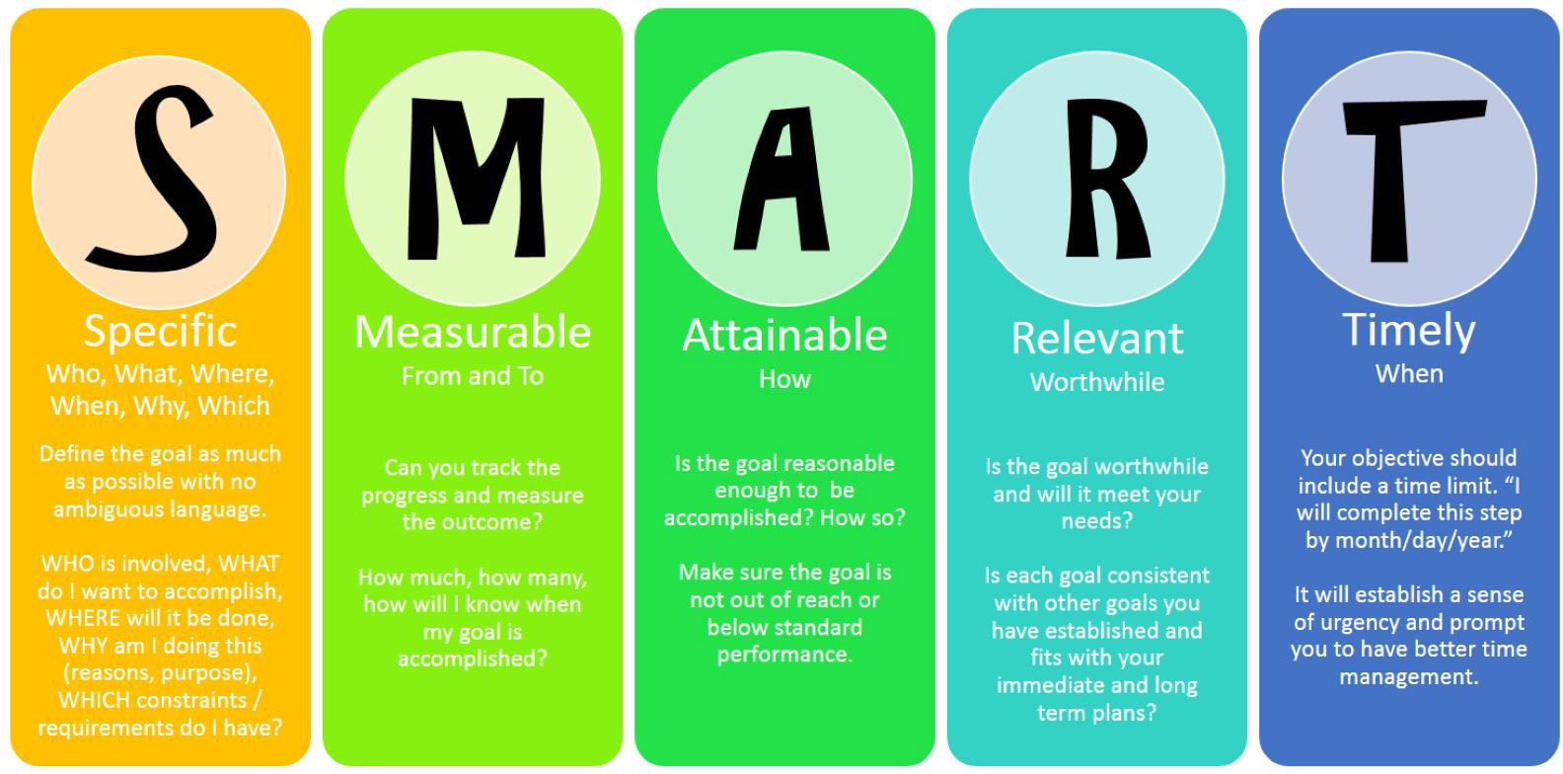

ACTIVITY LOG 3
COMPETENCY (1) Demonstrates Ethical & Professional Behavior
Field Specific Practice Behaviors
- Make ethical decisions by applying the NASW Code of Ethics standards, relevant laws and regulations, models for ethical decision-making, ethical conduct of research, and other codes of ethics as appropriate to context.
- Use reflection and self-regulation to manage personal values and maintain professionalism in practice situations.
- Demonstrate professional demeanor in behavior; appearance; and oral, written and electronic communication.
- Use technology ethically and appropriately to facilitate practice outcomes.
- Use supervision and consultation to guide professional judgment and behavior.
(from FVSSW Field Policy & Procedure Manual and Learning Contract)

Written Log-Submit via BrightSpace prior to class. This will be the basis for class discussion.
- Share general practicum experiences for the week. Be concise in your writing.
Social Work Professionals/Self, Safety and Supervision
Reflect on the field specific practice behaviors listed above and your initial days at practicum. Having observed other social work professionals at your setting, answer the following questions:
- Learn more about the agency you are placed at by reviewing their policy manual and/or other documents that can orient you to the agency.
  - What is the mission of the organization?
  - What other professionals/roles are there in the agency?
  - Are there other departments/programs that exist within the agency? If so, how do they work together to uphold the mission of the organization?
- Each student is required to have one hour of supervision per week; students are responsible for taking the lead in getting this scheduled. Have you developed a plan for a weekly meeting with your supervisor for supervision? If so, what does it look like? If not, what steps are you going to take in getting this scheduled?

ACTIVITY LOG 4
COMPETENCY (1) Demonstrates Ethical & Professional Behavior
Field Specific Practice Behaviors
- Make ethical decisions by applying the NASW Code of Ethics standards, relevant laws and regulations, models for ethical decision-making, ethical conduct of research, and other codes of ethics as appropriate to context.
- Use reflection and self-regulation to manage personal values and maintain professionalism in practice situations.
- Demonstrate professional demeanor in behavior; appearance; and oral, written and electronic communication.
- Use technology ethically and appropriately to facilitate practice outcomes.
- Use supervision and consultation to guide professional judgment and behavior.
(from FVSSW Field Policy & Procedure Manual and Learning Contract)

Written Log-Submit via BrightSpace prior to class. This will be the basis for class discussion.
- Share general practicum experiences for the week. Be concise in your writing.
Observation Activity
You are to arrive at your field practicum agency visualizing yourself as a client arriving for potential services. Answer the following questions:
- What are your first impressions in terms of location, accessibility, sights, sounds, smells, client-client interactions, client-staff interactions, staff-staff interactions?
- Are clients treated with respect? What is the language used when referring to clients?
- How is confidentiality of the clients handled?
- How are the core values of Social Work (service, social justice, dignity and worth of the person, importance of human relationships, integrity, and competence) demonstrated in the interactions with clients?

IN-CLASS ACTIVITY:

Professional Behavior and Communication

Your instructor will provide you with a case study in class. Using the “Habits of the Mind” and “Pitfalls and Remedies” handouts on the next pages, please answer the following questions in small groups:

- What are some challenges experienced by this team?
- How might they be addressed?
- What pitfalls have you seen in other groups?
- What are strategies to maintain professional behavior and communication in challenging situations?

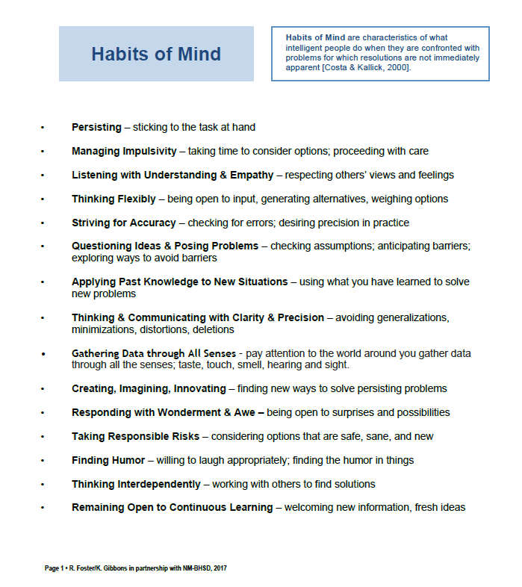
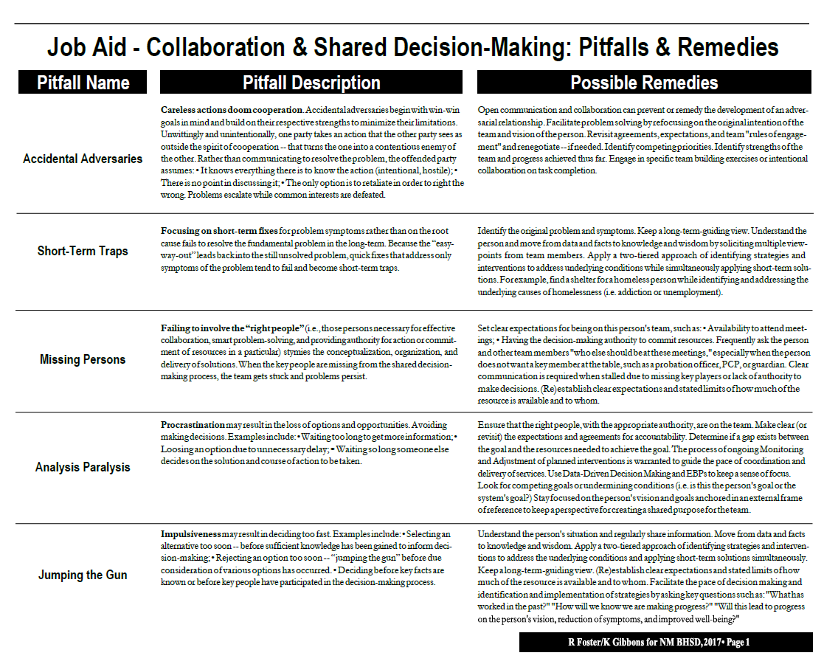
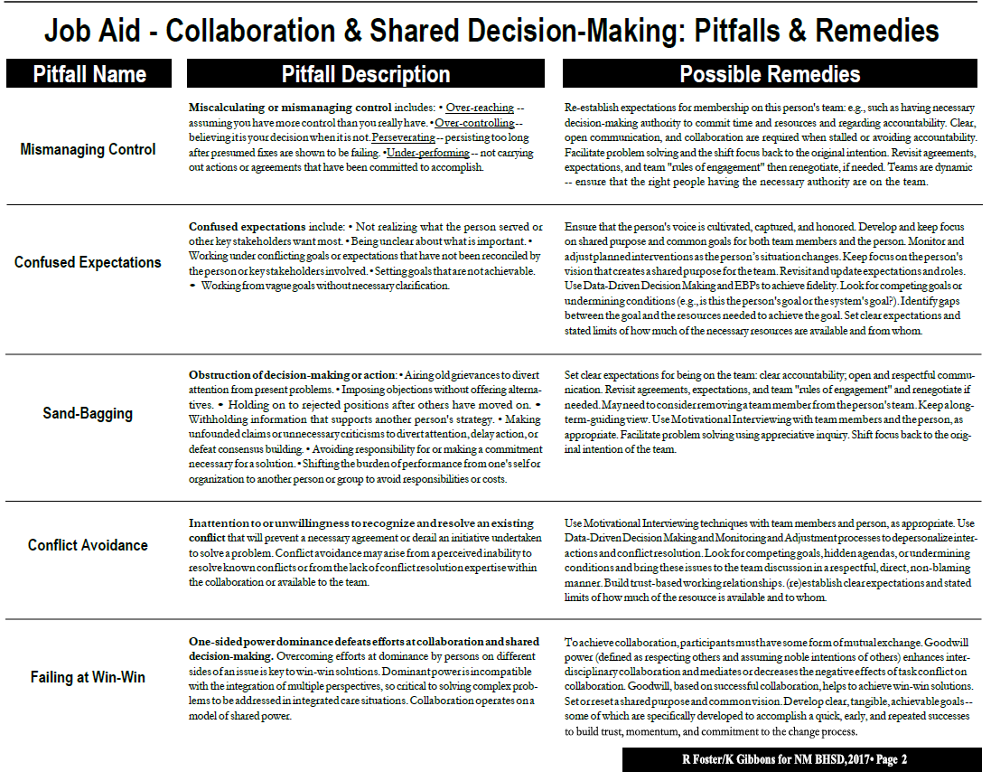
ACTIVITY LOG 5
COMPETENCY (1) Demonstrates Ethical & Professional Behavior
Field Specific Practice Behaviors
- Make ethical decisions by applying the NASW Code of Ethics standards, relevant laws and regulations, models for ethical decision-making, ethical conduct of research, and other codes of ethics as appropriate to context.
- Use reflection and self-regulation to manage personal values and maintain professionalism in practice situations.
- Demonstrate professional demeanor in behavior; appearance; and oral, written and electronic communication.
- Use technology ethically and appropriately to facilitate practice outcomes.
- Use supervision and consultation to guide professional judgment and behavior.
(from FVSSW Field Policy & Procedure Manual and Learning Contract)

Written Log-Submit via BrightSpace prior to class. This will be the basis for class discussion.
- Share general practicum experiences for the week. Be concise in your writing.
Critical Thinking Interview
- Interview a social worker preferably at your practicum site. Inquire about how the social worker has used the NASW Code of Ethics to guide their intervention strategy in an ethical dilemma.
Use of Technology
Describe the ways in which technology, oral, and written communication are used at the agency.
- How have you been trained/familiarized with these modes of communication? Has it been adequate?

ACTIVITY LOG 6
COMPETENCY (2) Engage Diversity and Difference in Practice
Field Specific Practice Behaviors
- Apply and communicate understanding of the importance of diversity and difference in shaping life experiences in practice at the micro, mezzo, and macro levels.
- Present themselves as learners and engage clients and constituencies as experts of their own experiences.
- Apply self-awareness and self-regulation to manage the influence of personal biases and values in working with diverse clients and constituencies.
(from FVSSW Field Policy & Procedure Manual and Learning Contract)

Written Log-Submit via BrightSpace prior to class. This will be the basis for class discussion.
- Share general practicum experiences for the week. Be concise in your writing.
Reflection on Diversity and Difference at Practicum Setting
In consultation with supervisor, discuss the diversity of staff in terms ethnicity, gender, age, ability. Answer the questions below after this discussion.
- Does the range of diversity reflect the client population served by the agency?
- Does diversity of staff affect the quality of service delivery?
- In your opinion, should staff composition reflect the client population served by the agency?
- Is there any training on diversity in your organization? If so, what is offered?
- Have you discussed bias in supervision?

ACTIVITY LOG 7
COMPETENCY (3) Advance Human Rights and Social, Economic, and Environmental Justice
Field Specific Practice Behaviors
- Apply their understanding of social, economic, and environmental justice to advocate for human rights at the individual and system levels.
- Engage in practices that advance social, economic, and environmental justice.
(from FVSSW Field Policy & Procedure Manual and Learning Contract)

Written Log-Submit via BrightSpace prior to class. This will be the basis for class discussion.
- Share general practicum experiences for the week. Be concise in your writing.
Social Justice Exercise
From your personal observation, answer the following questions:
- How aware do you think the agency is of the historical background (oppression and discrimination) of the population(s) served?
- How does the agency deliver services that consider the background of those populations?
- How will you use this information to inform your own practice?

ACTIVITY LOG 8
COMPETENCY (4) Engage in Practice-informed Research and Research-informed Practice
Field Specific Practice Behaviors
- Use practice experience and theory to inform scientific inquiry and research.
- Apply critical thinking to engage in analysis of quantitative and qualitative research methods and research findings.
- Use and translate research evidence to inform and improve practice, policy, and service delivery.
(from FVSSW Field Policy & Procedure Manual and Learning Contract)

Written Log-Submit via BrightSpace prior to class. This will be the basis for class discussion.
- Share general practicum experiences for the week. Be concise in your writing.
Informed Practice Exercise
- Does your agency collect data? How is it used to support the organizations efforts? For example, data could be shared in grant applications, employed to make improvements in service delivery, etc.
- What kinds of evidence-based practice does your agency use?
- Find out what you can about how the agency was founded. How were community needs identified? How did the agency originally determine its response to the needs? Ask your agency instructor if there is a founding member or board member you might be able to interview to learn more about the history of the organization.
- Discuss with your agency instructor the ways in which the agency has used data and/or research information to make practice decisions. Write up your response.

ACTIVITY LOG 9
COMPETENCY (5) Engage in Policy Practice
Field Specific Practice Behaviors
- Identify social policy at the local, state, and federal level that impacts well-being, service delivery, and access to social services.
- Assess how social welfare and economic policies impact the delivery of and access to social services.
- Apply critical thinking to analyze, formulate, and advocate for policies that advance human rights and social, economic, and environmental justice.
(from FVSSW Field Policy & Procedure Manual and Learning Contract)

Written Log-Submit via BrightSpace prior to class. This will be the basis for class discussion.
- Share general practicum experiences for the week. Be concise in your writing.

Policy Exercise
- If you haven’t done so already, read the agency policy and procedure manual.
- Is the policy reviewed or updated on a regular basis? What is the process? Who considers requests for change?
- Ask your instructor if there has been a recent change to the agency’s policies. What initiated the change? What were the intended outcomes? Did the change produce the expected results?
- Discuss agency policies with your agency instructor and ask how the policies of the agency impact the populations it serves. Write up your response.

ACTIVITY LOG 10
COMPETENCY (5) Engage in Policy Practice
Field Specific Practice Behaviors
- Identify social policy at the local, state, and federal level that impacts well-being, service delivery, and access to social services.
- Assess how social welfare and economic policies impact the delivery of and access to social services.
- Apply critical thinking to analyze, formulate, and advocate for policies that advance human rights and social, economic, and environmental justice.
(from FVSSW Field Policy & Procedure Manual and Learning Contract)

Written Log-Submit via BrightSpace prior to class. This will be the basis for class discussion.
- Share general practicum experiences for the week. Be concise in your writing.

Practice Contexts Exercise
Interview a social work or related professional who has been employed at the agency for five years or more and ask how the agency has changed over time regarding:
- scope of services
- mission of organization
- technology
- any other changes they would like to reflect on
Has it made the work easier or harder and why?

If you are unable to identify someone who has been with the agency for five years, interview a social worker who has been in the field five years or more about the changes they have seen in the profession since starting.

ACTIVITY LOG 11
COMPETENCY (6) Engage with Individuals, Families, Groups, Organizations, and Communities
Field Specific Practice Behaviors
- Apply knowledge of human behavior and the social environment, person-in-environment, and other multidisciplinary theoretical frameworks to engage with clients and constituencies.
- Use empathy, reflection and interpersonal skills to effectively engage diverse clients and constituencies.
(from FVSSW Field Policy & Procedure Manual and Learning Contract)

Engagement Observation
Written Log-Submit via BrightSpace prior to class. This will be the basis for class discussion.
- Share general practicum experiences for the week. Be concise in your writing.

Engagement Observation
From your observations, describe what you have learned about the process of ‘engagement’ at your practicum placement.
- How do the social workers prepare for action at these levels:
  - Individual
  - Family
  - Group
  - Organizational
  - Community
- What is the process for developing a mutually agreed-on focus of work and desired outcomes?
- How have you seen social workers at your agency build rapport? What skills or behaviors do you think help them to successfully build rapport?
- How have empathy and interpersonal skills been demonstrated?

ACTIVITY LOG 12
COMPETENCY (7) Assess Individuals, Families, Groups, Organizations, and Communities
Field Specific Practice Behaviors
- Collect and organize data, and apply critical thinking to interpret information from clients and constituencies.
- Apply knowledge of human behavior and the social environment, and other multidisciplinary theoretical frameworks in the analysis of assessment data from clients and constituencies.
- Develop mutually agreed-on intervention goals and objectives based on the critical assessment of strengths, needs, and challenges within clients and constituencies.
- Select appropriate intervention strategies based on the assessment, research knowledge, and values and preferences of clients and constituencies.
(from FVSSW Field Policy & Procedure Manual and Learning Contract)

Written Log-Submit via BrightSpace prior to class. This will be the basis for class discussion.
- Share general practicum experiences for the week. Be concise in your writing.
Assessment Observation
From your observations, describe what you have learned about the process of ‘assessment’ at your practicum placement.
- How is client data collected, interpreted, and organized?
- How are client’s strengths and limitations considered in the assessment process?
- Are intervention goals and objectives developed mutually with client?
- How do the social workers select appropriate intervention strategies?

IN CLASS ACTIVITY:
On following next page, you will find the “Clinical Questions” and “Case Formulation” worksheets, tools for assessment. For this activity, you will choose a famous fictional character from a movie, TV series, or book or your instructor will provide you with a case to complete the “Intervention Planning Worksheet” as a class or in small groups. You can note if there is still information needed.
After completing the worksheet, please answer the questions:
- How might you use this worksheet at your practicum?
- How could this be used for presenting a case with your supervisor?

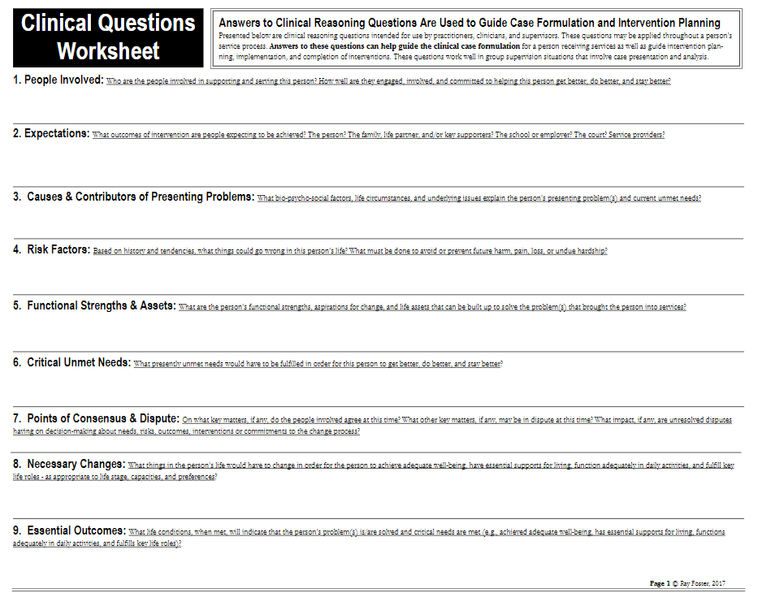
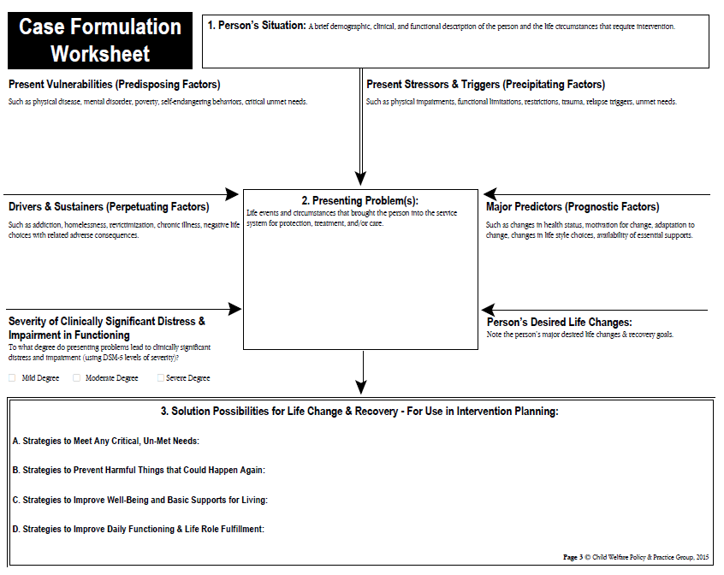

ACTIVITY LOG 13
COMPETENCY (8) Intervene with Individuals, Families, Groups, Organizations, and Communities
Field Specific Practice Behaviors
- Critically choose and implement interventions to achieve practice goals and enhance capacities of clients and constituencies.
- Apply knowledge of human behavior and the social environment, person-in-environment, and other multidisciplinary theoretical frameworks in interventions with clients and constituencies.
- Use inter-professional collaborations as appropriate to achieve beneficial practice outcomes.
- Negotiate, mediate and advocate with and on behalf of diverse clients and constituencies.
- Facilitate effective transitions and endings that advance mutually agreed-on goals.
(from FVSSW Field Policy & Procedure Manual and Learning Contract)

Written Log-Submit via BrightSpace prior to class. This will be the basis for class discussion.
- Share general practicum experiences for the week. Be concise in your writing.
Intervention Observation
From your observations, describe what you have learned about the process of ‘intervention’ at your practicum placement.
- What are some examples of interventions at your agency or organization?
- How are they implemented?
- How are clients or constituents helped to resolve problems?
- What inter-professional collaborations has the agency developed to support interventions? How do inter-professional interventions differ from those that only use agency programs or resources?
- How do the social workers negotiate, mediate, and advocate for clients?
- How do the social workers facilitate transitions and endings?

ACTIVITY LOG 14
COMPETENCY (9) Evaluate Practice with Individuals, Families, Groups, Organizations, and Communities
Field Specific Practice Behaviors
- Select and use appropriate methods for evaluation of outcomes.
- Apply knowledge of human behavior and the social environment, person-in-environment, and other multidisciplinary theoretical frameworks in the evaluation of outcomes.
- Critically analyze, monitor, and evaluate intervention and program processes and outcomes.
- Apply evaluation findings to improve practice effectiveness at the micro, mezzo, and macro levels.
(from FVSSW Field Policy & Procedure Manual and Learning Contract)

Written Log-Submit via BrightSpace prior to class. This will be the basis for class discussion.
- Share general practicum experiences for the week. Be concise in your writing.

Evaluation Observation
From your observations, describe what you have learned about the process of ‘evaluation’ at your practicum placement.
- Ask your agency instructor, how do they know if an intervention is working?
- How does the agency critically analyze, monitor, and evaluate interventions? Who does that work?
- How does the agency use data received from evaluations to improve practice with:
  - Individuals
  - Families
  - Groups
  - Organizations
  - Communities

ACTIVITY LOG 15
REVIEW OF COMPETENCIES 6, 7, 8, & 9:
- Competency 6: Engage with Individuals, Families, Groups, Organizations, and Communities
- Competency 7: Assess Individuals, Families, Groups, Organizations, and Communities
- Competency 8: Intervene with Individuals, Families, Groups, Organizations, and Communities
- Competency 9: Evaluate Practice with Individuals, Families, Groups, Organizations, and Communities

Written Log-Submit via BrightSpace prior to class. This will be the basis for class discussion.
- Share general practicum experiences for the week. Be concise in your writing.
Practice Theory Exercise
Ask your supervisor about the predominant practice theories that guide the delivery of services at your practicum agency and describe how these theories are reflected in the service delivery.
- Are there other practice theories that might be helpful for the population the agency serves?
- Which theories do you see guiding your practice as a social worker?

ACTIVITY LOG 16

Written Log-Submit via BrightSpace prior to class. This will be the basis for class discussion.
- Share general practicum experiences for the week. Be concise in your writing.

Wrap-Up/Reflection of Practicum Experience

- After a semester in practicum, how do you feel about your practicum and why?
- What’s been the hardest thing in your placement?
- What have you enjoyed the most?
- What have you learned the most in your practicum?
- What are you looking forward to?

Be prepared to discuss how you will update the learning contract for second semester so that this can be presented to the agency instructor and field consultant during the final evaluation meeting.

Danowski, W.A. (2012). In the field: A guide for the social work practicum. (2nd ed.). Boston: Pearson Education, Inc.
Birkenmaier, J., & Berg-Weger. M. (2007). The practicum companion for social work: Integrating class and fieldwork. (2nd ed.) Boston: Pearson Education, Inc.

