New Mexico Highlands University
School of Social Work
Second Semester
FIELD PRACTICUM ACTIVITY LOG- SOWK 4520
STUDENT NAME____________________________________________________________________
PRIMARY CONTACT NUMBER ________/________/_____ E-MAIL ___________________________

CLASSIFICATION

_____ BSW
AGENCY_________________________________________________
AGENCY INSTRUCTOR _______________________CO-INSTRUCTOR _________________________
FIELD CONSULTANT________________________________
ACTIVITY LOG GUIDELINES
The major objective of the field practicum seminar and the activity log is to encourage students to utilize the nine CSWE competencies and relevant practice behaviors to critically think about the theoretical and conceptual contribution of the classroom with the field practicum. Students are required to maintain a weekly (typed) log and submit weekly or bi-weekly (depending on how often seminar meets), to field seminar instructor throughout the entire semester. All entries and discussions of your log in the classroom setting must protect client and agency confidentiality and cannot contain identifying information. You are not required to share the activity log with your agency instructor. Logs are to be shared in the field seminar class.

The purpose of the activity log is to encourage students to:
- Critically contemplate the ways in which the social work competencies are operationalized (put into practice) in your field practicum setting.
- Complete weekly activities/assignments focused on the building blocks of social work practice in the field setting.
- Establish an ongoing dialog with agency instructor, field consultant and field seminar instructor in order to experience the field practicum as an integrated aspect of your learning.
- Write clear and concise narratives of your weekly experiences.
- Examine personal expectations of self as learner in the field setting
- Critically integrate material from practice, human behavior, research and policy into your field experience.
- Learn to use field instruction effectively.

ACTIVITY LOG 1
(in class exercise)
Reflection on the Field of Social Work/Practicum
Reminder: new learning contract must be submitted by the 3rd week of the semester. Answer the following questions and be prepared to share with the class.

- What social work skills did you develop in your first semester of practicum?

- What areas of improvement will you focus on during your second semester of practicum?

____________________________________________________________________________________
Share general practicum concerns and experiences for the week.

ACTIVITY LOG 2
(in class exercise)
Development/discussion of learning contract
Reference the ideas you wrote in Activity Log 1-first semester regarding what you wanted to learn in your field practicum. Write down and discuss the practice activities you would like to fulfill in your second semester of practicum.

____________________________________________________________________________________Share general practicum concerns and experiences for the week.

ACTIVITY LOG 3
COMPETENCY (1) Demonstrates Ethical & Professional Behavior
Field Specific Practice Behaviors
- Make ethical decisions by applying the NASW Code of Ethics standards, relevant laws and regulations, models for ethical decision making, ethical conduct of research, and other codes of ethics as appropriate to context.
- Use reflection and self-regulation to manage personal values and maintain professionalism in practice situations.
- Demonstrate professional demeanor in behavior; appearance; and oral, written and electronic communication.
- Use technology ethically and appropriately to facilitate practice outcomes.
- Use supervision and consultation to guide professional judgment and behavior.

Written Log-Submit via Brightspace prior to class. This will be the basis for class discussion.
- Share general practicum experiences for the week. Be concise in your writing.
Reflection on Social Work Professionals/Self
Review the Reflection on Social Work Professionals/Self you completed the first semester in Activity Log 3. Describe how you’ve identified as a professional social worker at your practicum and how you plan to improve in your professional role for your second semester referencing the practice behaviors listed above.

ACTIVITY LOG 4
COMPETENCY (1) Demonstrates Ethical & Professional Behavior
Field Specific Practice Behaviors
- Make ethical decisions by applying the NASW Code of Ethics standards, relevant laws and regulations, models for ethical decision making, ethical conduct of research, and other codes of ethics as appropriate to context.
- Use reflection and self-regulation to manage personal values and maintain professionalism in practice situations.
- Demonstrate professional demeanor in behavior; appearance; and oral, written and electronic communication.
- Use technology ethically and appropriately to facilitate practice outcomes.
- Use supervision and consultation to guide professional judgment and behavior.

Written Log-Submit via Brightspace prior to class. This will be the basis for class discussion.
- Share general practicum experiences for the week. Be concise in your writing.
Observation Activity
Review the Observation Activity you completed in your first semester in Activity Log 4. Having been at the practicum for one semester, assess the following facets of your experiences since that time and write them down:
- Did your perceptions of the agency/staff change from last semester when you originally conducted the observation activity? If they did change, how did they change?
- What constitutes ethical behavior at your agency?
- Are clients treated respectfully?
- How is confidentiality of files/client visits handled?
- After completing the observation activity in the first semester, did you give any feedback to the agency about what you observed? Why/why not?

Reflect on your experiences during seminar.
IN-CLASS ACTIVITY:

Recognizing and understanding Bias

Please review “Job Aid: Errors in Clinical Reasoning” on the following page and discuss these questions in class or small groups:

- How might different types of bias or errors in reasoning affect a social worker’s judgement? Practice?
- How might these biases or errors be addressed?
- What do you think is the role of supervision in identifying and managing bias?
- What tools have helpful for you in understanding your own biases?
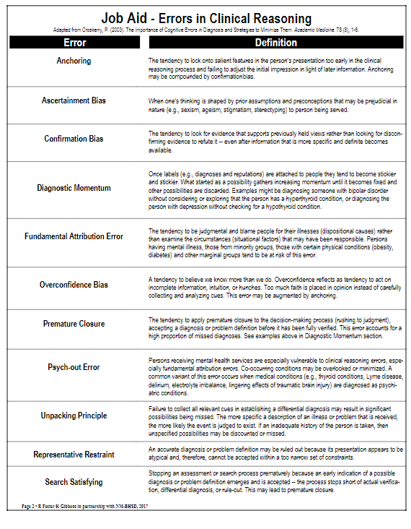
ACTIVITY LOG 5
COMPETENCY (1) Demonstrates Ethical & Professional Behavior
Field Specific Practice Behaviors
- Make ethical decisions by applying the NASW Code of Ethics standards, relevant laws and regulations, models for ethical decision making, ethical conduct of research, and other codes of ethics as appropriate to context.
- Use reflection and self-regulation to manage personal values and maintain professionalism in practice situations.
- Demonstrate professional demeanor in behavior; appearance; and oral, written and electronic communication.
- Use technology ethically and appropriately to facilitate practice outcomes.
- Use supervision and consultation to guide professional judgment and behavior.

Written Log-Submit via Brightspace prior to class. This will be the basis for class discussion.
- Share general practicum experiences for the week. Be concise in your writing.
Critical Thinking Exercise
Review the Critical Thinking Exercise you completed the first semester in Activity Log 5. Write about an experience you’ve had in field practicum that required you to apply critical thinking in your effort to problem solve a particular situation.

ACTIVITY LOG 6
COMPETENCY (2) Engage Diversity and Difference in Practice
Field Specific Practice Behaviors
- Apply and communicate understanding of the importance of diversity and difference in shaping life experiences in practice at the micro, mezzo, and macro levels.
- Present themselves as learners and engage clients and constituencies as experts of their own experiences.
- Apply self-awareness and self-regulation to manage the influence of personal biases and values in working with diverse clients and constituencies.

Written Log-Submit via Brightspace prior to class. This will be the basis for class discussion.
- Share general practicum experiences for the week. Be concise in your writing.
Reflection on Diversity at Practicum Setting
Review the Diversity Exercise you completed the first semester of practicum in Activity Log 6. Since that time, describe how you’ve gained self-awareness of personal biases in your work with clients.

ACTIVITY LOG 7
COMPETENCY (3) Advance Human Rights and Social, Economic, and Environmental Justice
Field Specific Practice Behaviors
- Apply their understanding of social, economic, and environmental justice to advocate for human rights at the individual and system levels.
- Engage in practices that advance social, economic, and environmental justice.

Written Log-Submit via Brightspace prior to class. This will be the basis for class discussion.
- Share general practicum experiences for the week. Be concise in your writing.
Social Justice Exercise
Review the Social Justice Exercise you completed the first semester in Activity Log 7. In your own words, what does social justice mean to you?

ACTIVITY LOG 8
COMPETENCY (4) Engage in Practice-informed Research and Research-informed Practice
Field Specific Practice Behaviors
- Use practice experience and theory to inform scientific inquiry and research.
- Apply critical thinking to engage in analysis of quantitative and qualitative research methods and research findings.
- Use and translate research evidence to inform and improve practice, policy, and service delivery.

Written Log-Submit via Brightspace prior to class. This will be the basis for class discussion.
- Share general practicum experiences for the week. Be concise in your writing.
Informed Practice Exercise
Review the Informed Practice Exercise you completed the first semester in Activity Log 8. Based on what your supervisor shared with you, do you think that data and/or informed research information is used to inform practice decisions at your practicum setting? Why or why not?

Danowski, W.A. (2012). In the field: A guide for the social work practicum. (2nd ed.). Boston: Pearson Education, Inc.
Birkenmaier, J., & Berg-Weger. M. (2007). The practicum companion for social work: Integrating class and fieldwork. (2nd ed.) Boston: Pearson Education, Inc.
ACTIVITY LOG 9
COMPETENCY (5) Engage in Policy Practice
Field Specific Practice Behaviors
- Identify social policy at the local, state, and federal level that impacts well-being, service delivery, and access to social services.
- Assess how social welfare and economic policies impact the delivery of and access to social services.
- Apply critical thinking to analyze, formulate, and advocate for policies that advance human rights and social, economic, and environmental justice.

Written Log-Submit via Brightspace prior to class. This will be the basis for class discussion.
- Share general practicum experiences for the week. Be concise in your writing.
Policy Exercise
Review the Policy Exercise you completed the first semester in Activity Log 9. Based on what your supervisor shared with you, do you think that data and/or informed research information is used to inform practice decisions at your practicum setting? Why or why not?

Danowski, W.A. (2012). In the field: A guide for the social work practicum. (2nd ed.). Boston: Pearson Education, Inc.
Birkenmaier, J., & Berg-Weger. M. (2007). The practicum companion for social work: Integrating class and fieldwork. (2nd ed.) Boston: Pearson Education, Inc.
ACTIVITY LOG 10
COMPETENCY (5) Engage in Policy Practice
Field Specific Practice Behaviors
- Identify social policy at the local, state, and federal level that impacts well-being, service delivery, and access to social services.
- Assess how social welfare and economic policies impact the delivery of and access to social services.
- Apply critical thinking to analyze, formulate, and advocate for policies that advance human rights and social, economic, and environmental justice.

Written Log-Submit via Brightspace prior to class. This will be the basis for class discussion.
- Share general practicum experiences for the week. Be concise in your writing.
Practice Contexts Exercise
Review the Practice Contexts Exercise you completed the first semester in Week 10. Based on what your supervisor shared with you, how do you the practice of social work at your agency continuing to change over the next five years?
- scope of services
- mission of organization
- technology
- any other changes

Danowski, W.A. (2012). In the field: A guide for the social work practicum. (2nd ed.). Boston: Pearson Education, Inc.
Birkenmaier, J., & Berg-Weger. M. (2007). The practicum companion for social work: Integrating class and fieldwork. (2nd ed.) Boston: Pearson Education, Inc.
ACTIVITY LOG 11
COMPETENCY (6) Engage with Individuals, Families, Groups, Organizations, and Communities
Field Specific Practice Behaviors
- Apply knowledge of human behavior and the social environment, person-in-environment, and other multidisciplinary theoretical frameworks to engage with clients and constituencies.
- Use empathy, reflection and interpersonal skills to effectively engage diverse clients and constituencies.

Written Log-Submit via Brightspace prior to class. This will be the basis for class discussion.
- Share general practicum experiences for the week. Be concise in your writing.
Engagement Observation
From your observations, describe what you have learned about the process of ‘engagement’ at your practicum placement.
- How do the social workers prepare for action?
- How has empathy and interpersonal skills been demonstrated?
- What is the process for developing a mutually agreed-on focus of work and desired outcomes?

Danowski, W.A. (2012). In the field: A guide for the social work practicum. (2nd ed.). Boston: Pearson Education, Inc.
Birkenmaier, J., & Berg-Weger. M. (2007). The practicum companion for social work: Integrating class and fieldwork. (2nd ed.) Boston: Pearson Education, Inc.
ACTIVITY LOG 12
COMPETENCY (7) Assess Individuals, Families, Groups, Organizations, and Communities
Field Specific Practice Behaviors
- Collect and organize data, and apply critical thinking to interpret information from clients and constituencies.
- Apply knowledge of human behavior and the social environment, and other multidisciplinary theoretical frameworks in the analysis of assessment data from clients and constituencies.
- Develop mutually agreed-on intervention goals and objectives based on the critical assessment of strengths, needs, and challenges within clients and constituencies.
- Select appropriate intervention strategies based on the assessment, research knowledge, and values and preferences of clients and constituencies.

Written Log-Submit via Brightspace prior to class. This will be the basis for class discussion.
- Share general practicum experiences for the week. Be concise in your writing.
Assessment Observation
From your observations, describe what you have learned about the process of ‘assessment’ at your practicum placement.
- How is client data collected, interpreted, and organized?
- How are client’s strengths and limitations considered in the assessment process?
- Are intervention goals and objectives developed mutually with client?
- How do the social workers select appropriate intervention strategies?

Danowski, W.A. (2012). In the field: A guide for the social work practicum. (2nd ed.). Boston: Pearson Education, Inc.
Birkenmaier, J., & Berg-Weger. M. (2007). The practicum companion for social work: Integrating class and fieldwork. (2nd ed.) Boston: Pearson Education, Inc.

ACTIVITY LOG 13
COMPETENCY (8) Intervene with Individuals, Families, Groups, Organizations, and Communities
Field Specific Practice Behaviors
- Critically choose and implementing interventions to achieve practice goals and enhance capacities of clients and constituencies.
- Apply knowledge of human behavior and the social environment, person-in-environment, and other multidisciplinary theoretical frameworks in interventions with clients and constituencies.
- Use inter-professional collaborations as appropriate to achieve beneficial practice outcomes.
- Negotiate, mediate and advocate with and on behalf of diverse clients and constituencies.
- Facilitate effective transitions and endings that advance mutually agreed-on goals.

Written Log-Submit via Brightspace prior to class. This will be the basis for class discussion.
- Share general practicum experiences for the week. Be concise in your writing.
Intervention Observation
From your observations, describe what you have learned about the process of ‘intervention’ at your practicum placement.
- How are actions initiated to achieve organizational goals?
- How are prevention interventions that enhance client capacities implemented?
- How are clients helped to resolve problems?
- How do the social workers negotiate, mediate, and advocate for clients?
- How do the social workers facilitate transitions and endings?

IN CLASS ACTIVITY:
On the following pages, you will find the job aid, “Intervention Planning Guidance,” and “Intervention Planning Worksheet,” a tool to assist in determining outcomes and interventions. For this activity, you will choose a famous fictional character from a movie, TV series, or book or your instructor will provide you with a case to complete the “Intervention Planning Worksheet” as a class or in small groups.
After completing the worksheet, please answer the questions:
- How did the outcomes inform the interventions you selected?
- How might you use this worksheet at your practicum?
- Which “points of guidance in treatment planning” were the most helpful and why?

Danowski, W.A. (2012). In the field: A guide for the social work practicum. (2nd ed.). Boston: Pearson Education, Inc.
Birkenmaier, J., & Berg-Weger. M. (2007). The practicum companion for social work: Integrating class and fieldwork. (2nd ed.) Boston: Pearson Education, Inc.
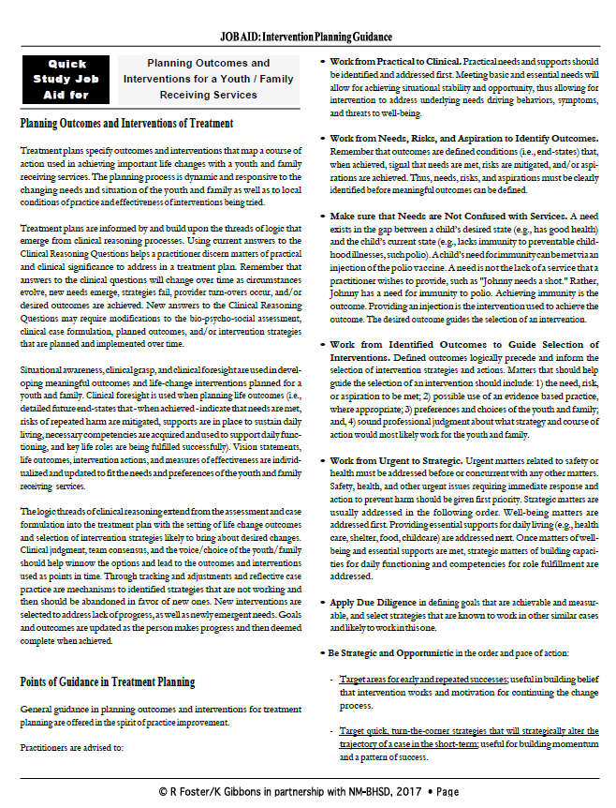
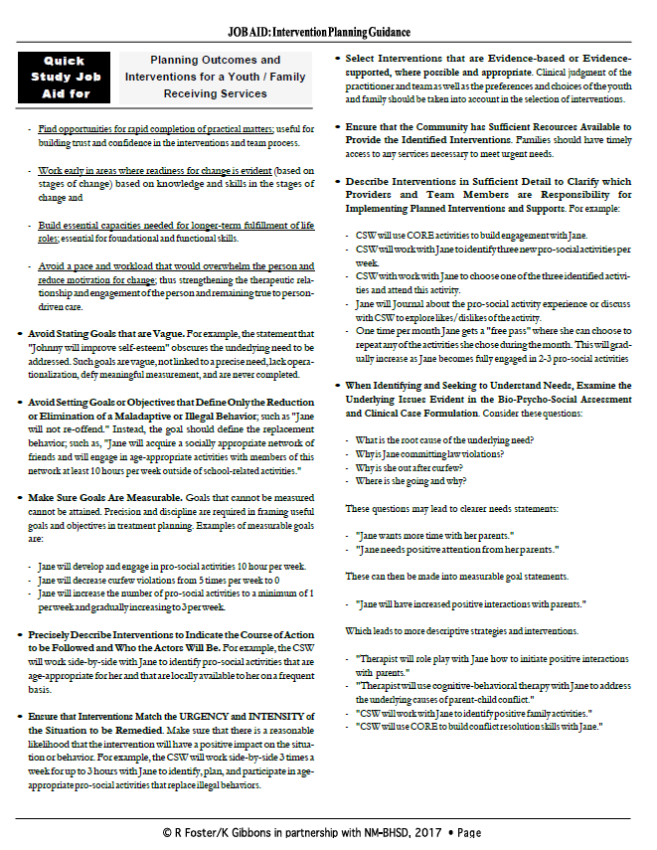

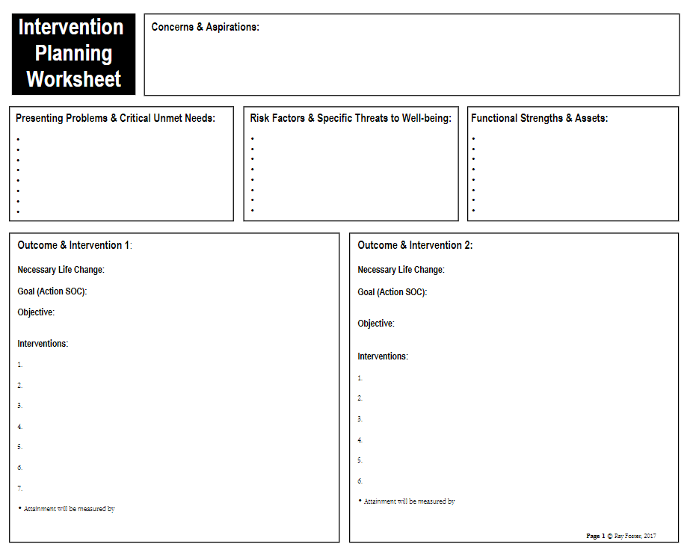
ACTIVITY LOG 14
COMPETENCY (9) Evaluate Practice with Individuals, Families, Groups, Organizations, and Communities
Field Specific Practice Behaviors
- Select and use appropriate methods for evaluation of outcomes.
- Apply knowledge of human behavior and the social environment, person-in-environment, and other multidisciplinary theoretical frameworks in the evaluation of outcomes.
- Critically analyze, monitor, and evaluate intervention and program processes and outcomes.
- Apply evaluation findings to improve practice effectiveness at the micro, mezzo, and macro levels.

Written Log-Submit via Brightspace prior to class. This will be the basis for class discussion.
- Share general practicum experiences for the week. Be concise in your writing.
Evaluation Observation
From your observations, describe what you have learned about the process of ‘evaluation’ at your practicum placement.
- How do social workers critically analyze, monitor, and evaluate interventions?

Danowski, W.A. (2012). In the field: A guide for the social work practicum. (2nd ed.). Boston: Pearson Education, Inc.
Birkenmaier, J., & Berg-Weger. M. (2007). The practicum companion for social work: Integrating class and fieldwork. (2nd ed.) Boston: Pearson Education, Inc.
ACTIVITY LOG 15
REVIEW OF COMPETENCIES 6, 7, 8, & 9:
- Competency 6: Engage with Individuals, Families, Groups, Organizations, and Communities
- Competency 7: Assess Individuals, Families, Groups, Organizations, and Communities
- Competency 8: Intervene with Individuals, Families, Groups, Organizations, and Communities
- Competency 9: Evaluate Practice with Individuals, Families, Groups, Organizations, and Communities

Written Log-Submit via Brightspace prior to class. This will be the basis for class discussion.
- Share general practicum experiences for the week. Be concise in your writing.
Practice Theory Exercise
Ask your supervisor about the predominant practice theories that guide the delivery of services at your practicum agency and describe how these theories are reflected in the service delivery. If there are no predominant theories that guide practice at the agency, explain.

Danowski, W.A. (2012). In the field: A guide for the social work practicum. (2nd ed.). Boston: Pearson Education, Inc.
Birkenmaier, J., & Berg-Weger. M. (2007). The practicum companion for social work: Integrating class and fieldwork. (2nd ed.) Boston: Pearson Education, Inc.

ACTIVITY LOG 16
Written Log-Submit via Brightspace prior to class. This will be the basis for class discussion.
- Share general practicum experiences for the week. Be concise in your writing.

Wrap-Up/Reflection of Practicum Experience

- What experiences and learning in practicum have had the most impact on your development as a professional social worker?

- What is the greatest challenge you overcame while in placement? What tools or skills did you utilize to do so?

- What accomplishments will you celebrate?

Danowski, W.A. (2012). In the field: A guide for the social work practicum. (2nd ed.). Boston: Pearson Education, Inc.
Birkenmaier, J., & Berg-Weger. M. (2007). The practicum companion for social work: Integrating class and fieldwork. (2nd ed.) Boston: Pearson Education, Inc.

