Department of History & Political Science

Graduate Program Manual

Department of History & Political Science

Douglas Hall

College of Arts & Sciences

New Mexico Highlands University

2021-2022

Table of Contents

Introductory Matter 4
Welcome 4
Department of History & Political Science Graduate Manual Rationale 4
General Information 4
Overview of the Programs in History & Political Science 4
Meeting National Standards & Student Needs 5
About the Faculty 5

Graduate Program Policies 7
Applying to the Programs 7
Program Requirements 7
Program Expectations 8
Double Counting Undergraduate and Graduate Credits 9
Incompletes 9
Timely Completion of the Program 9
Minimum Grade-Point 9
Standards of Professional Conduct 9
Academic Dishonesty & Plagiarism 10
Advising 10
Academic Program of Study 10
Transfer Credit 11
Independent Study & Supervised Research 11
Practicum, Internship, & Field Project 11
Course Substitutions 12
Change of Concentration 12
Postponing Completion of the Program 12

Graduate Assistantship
Applying for a Graduate Assistantship 13
Graduate Assistant Duties & Responsibilities 13

Thesis. Professional Paper, & Comprehensive Exam 15
Thesis
Thesis Advisor 15
Thesis Topic 15
Thesis Committee 16
Writing the Thesis 16
Oral Examination & Thesis Defense 17
Preparation of the Final Copy of the Thesis 17
Postponing Completion of the Thesis 18

Professional Paper 18
Comprehensive Exam 18

Graduation, Commencement, & Posting of the Degree 19

Financial Aid 20

Appendices 21
1.) M.A. Degree Maps 21
2.) Worksheets 23
Public Affairs/Concentration in Political & Governmental Processes 24
Public Affairs/Concentration in History………………………………..25
Southwest Studies/Concentration in History & Political Science……...26

3.) Programs of Study Forms……………………………………………………….27
Public Affairs/Concentration in Political & Governmental Processes....28
Public Affairs/Concentration in History………………………………..29
Southwest Studies/Concentration in History & Political Science……...30

4.) Various Graduate Program Forms 31

Introductory Matter

Welcome
The Department of History & Political Science would like to introduce you to its M.A. program at New Mexico Highlands University. While our department’s graduate component is small, that very smallness means that we can better serve our students. Please know that we take both pride and pleasure in doing our best for you, and should you have any questions about any aspect of our program, please don’t hesitate to ask any member of the department.

Department of History & Political Science Graduate Program Manual Rationale
This document is designed to provide you with information specific to the History & Political Science Master of Arts programs. While some of its contents repeat what can be found in the current versions of the Graduate Catalog and the Graduate Student Handbook, the department-specific Graduate Manual is not a substitute for them, and it is incumbent upon all students in our program to familiarize themselves with all of the policies and guidelines described therein.

General Information
New Mexico Highlands University, located in Las Vegas, New Mexico, was founded in 1893. For more information about the history of the institution, please see Defining our Destiny: The History of New Mexico Highlands University (1993) by our own Dr. Maurilio E. Vigil, Professor of Political Science Emeritus.

Graduate Programs at NMHU
New Mexico Highlands University offers a wide array of graduate programs, with students coming from both around the United States and the world. For details about all of these programs, please consult the NMHU Graduate Catalog, which is available on the NMHU website (www.nmhu.edu/).

The Office of Graduate Studies
The Office of Graduate Studies oversees all NMHU graduate programs, including policies, admissions, and assistantships. For particulars about the Office, please go to its website at https://www.nmhu.edu/office-of-graduate-studies/.

Overview of the Graduate Programs in History & Political Science
The faculty of History & Political Science participate jointly with faculty in Anthropology and Sociology in three interdisciplinary programs leading to a Master of Arts degree. These are the Public Affairs program, with its two Concentrations, (1) Political & Governmental Processes and (2) History, along with (3) the Southwest Studies program, Concentration in History & Political Science.

Highlands enjoys a unique position here in the Southwest, situated as we are where the Rocky Mountains meet the Great Plains and where three great cultural traditions come together. Our programs are built to take advantage of these three traditions as well as our rich variety of local resources.

Our programs are intended to serve individuals wanting to pursue the Master’s as a terminal degree; a Ph.D. in History or Political Science; a J.D. in law school; secondary middle and high school teaching; community college teaching; and careers in museum or governmental service.

Meeting National Standards & Student Needs
The History & Political Science faculty are committed to ensuring that its graduate programs remain nationally current plus continue to meet the needs of our students, even as those needs may change over time. Because of this commitment, both the Public Affairs and Southwest Studies programs undergo continuous evaluation. These evaluations are based, in large part, on an assessment of how well the program is meeting its intended outcomes. Copies of our Outcomes Assessment plans are available in the department office, as are our latest Outcomes Assessment reports; they are also available online at the Highlands website. In addition, all of the graduate programs of New Mexico Highlands University are subject to periodic review as a condition of the University’s membership in the Council of Graduate Schools plus as part of the national accreditation process overseen by the Higher Learning Commission (typically this takes place every ten years).

On occasion – in various classes, at the end of the program, as well as after graduation – you will be asked for feedback; please know that your responses on such surveys help us greatly and we thank you in advance for your cooperation.

About the Faculty

Dr. Elaine Rodriquez/Political Science & Department Chair. Dr. Rodriquez received her M.A. in Public Affairs from New Mexico Highland University and a Ph.D. in American Politics and Public Administration from Northern Arizona University. Her research focuses on Latino/a Politics and Immigration. She is the author of The 1993 National Voter Registration Act: Impact and Implications for Arizona’s Latino and Non-Latino Communities (2009) and has authored and co-authored various organizational reports. She is currently a member of the Las Vegas City Council (2020-2024) and is part of the administrative team for the 2020/2021 NMHU Legislative Leadership Fellowship Program. She is the founder of the Institute for Community Action Research (ICARE) and co-founder of Latina Research Associates, LLP. Her regular teaching responsibilities include undergraduate and graduate courses on American Politics, Public Policy, Public Administration, Research Methods, and Organizational Leadership.

Dr. Luke Ritter/History. Dr. Ritter received his Ph.D. in American History from Saint Louis University. He specializes in nineteenth-century immigration, nativism, and religion in the midwestern United States. He is the author of Inventing America’s First Immigration Crisis: Political Nativism in the Antebellum West (New York: Fordham University Press, 2020), as well as numerous scholarly articles and book reviews. His regular teaching responsibilities include undergraduate and graduate courses on U.S. history from the Colonial Era to the present.

Dr. Peter S. Linder/History. Dr. Linder received his B.A. in History and M.A. in Latin American History from the University of New Mexico and his Ph.D. In Latin American History from the University of Texas at Austin. His research interests include Venezuelan History and the History of Las Vegas and northeastern New Mexico. He is currently working on a study of Spanish-indigenous relations in the Province of Maracaibo, Venezuela in the eighteenth and early nineteenth centuries. His teaching responsibilities include undergraduate and graduate courses in Latin American, Southwestern, and New Mexico history, and on History through Film.

Dr. Steven J. Williams/History. Dr. Williams received his B.A. in Philosophy from Rutgers College and a Ph.D. in Medieval History from Northwestern University. His research is focused on high and late medieval intellectual and cultural history. He has a number of article publications and conference presentations to his credit, and in 2003 the University of Michigan Press published his book, The Secret of Secrets. The Scholarly Career of a Pseudo-Aristotelian Text in the Latin Middle Ages. His regular teaching responsibilities include courses on European history from Antiquity to the present; Research Methods for both undergraduates and graduate students; and the graduate seminar Contemporary Historical Thought.

Graduate Program Policies

Applying to the Programs
Although the Public Affairs and Southwest Studies programs adhere to the general NMHU admission guidelines, each program conducts its own selection and admissions process for all graduate applications. Applications are reviewed on an ongoing basis throughout the academic year. Although there is no application deadline, students are encouraged to apply early during the Spring semester for the following academic year, especially those persons desiring an Assistantship, since these awards are typically decided sometime in April and documentation must be complete by the time decisions are made.

For specifics about the application process, including policies and procedures, please see the NMHU Graduate Student Catalog.

Program Requirements
All program requirements are detailed in the current version of the Graduate Catalog.

The graduate programs in which History & Political Science participate are designed to facilitate student intellectual growth and professional success. Program requirements reflect this; specifically, Core curricula have been carefully designed in order to foster the necessary knowledge and capabilities to complete a student’s chosen program successfully.

Both the Public Affairs and Southwest Studies programs have required Core curricula. For the completion of the Master’s degree, students must satisfy the Core curriculum of their selected program, complete the research requirement by taking History/Political Science 620 Research Methods, and take additional coursework selected in consultation with a faculty advisor for a total of at least 36 hours.

For questions regarding course requirements or the development of a program of study, please contact the appropriate Graduate Coordinator or the student’s Academic Advisor.
Graduate Coordinator for Political Science: Dr. Elaine Rodriquez
Graduate Coordinator for History: Dr. Peter Linder
Graduate Coordinator for Southwest Studies: Dr. Peter Linder
Of course other members of the department are also available for consultation.

When planning one’s schedule, it is important to keep in mind that required courses are not necessarily offered every semester. Some are offered only once a year, or once every two years. The student should consult with the Graduate Advisor and/or the Graduate Coordinator in order to ensure that the required courses are taken when offered and to avoid delays in the completion of the Program of Study. In the end, however, it is the student’s responsibility to ensure that all program requirements are met. Please also note that poor planning cannot be “corrected” by Substitutions or Independent Study courses (see the sections on these topics below).

All program concentrations are independent one of the other and cannot be “mixed and matched” in order to “customize” a Program of Study. Dual concentrations involving the sharing of the Core within a program are only possible when a student fulfills all the requirements (i.e., courses and Thesis/Professional Paper) specific to each program; what this means in practical terms is that the student will be taking many more courses than in one concentration alone plus preparing a Thesis/Professional Paper in order to cover both concentrations. Paperwork for the two concentrations (including each Concentration-specific Program of Study) has to be filed separately in each department and the student will have two program advisors. Finally, it is the responsibility of the student to coordinate the two programs, not the faculty’s.

Program Expectations
Successful applicants should be able to perform well in a challenging academic environment and demonstrate the personal and professional characteristics necessary for graduate study.

It might be worth providing a reminder that graduate school is harder than undergraduate school. Following university and national norms for university education, undergraduate students are expected to put in at least two hours of work outside of class for every hour that they are in class; in other words, that undergraduate students will allot a minimum of six hours of work per week per course (not including time spent in the classroom). In most people’s experience, this is a lot more than what we did in high school. And just as the amount of work at the undergraduate level exceeds that expected in high school, so the demands of graduate school are greater than those encountered by undergraduates. Given that it is graduate school, and given that a full-time load is nine class hours (as opposed to fifteen hours for undergraduates), the expectation for hours worked per week will necessarily be somewhat higher than described in this paragraph’s second sentence.

It is strongly recommended that students limit themselves to nine credit hours per semester. While students may choose to take twelve credit hours in a semester, it is not recommended, especially if the student has a job (including a Graduate Assistantship) or a family.

Attending all class meetings, being in class on time, and comporting oneself properly in class are three other expectations in our graduate program. Here are some basic rules to follow:
• Attendance at every class meeting is required. This is especially important with respect to seminars meeting only once a week. (For the official NMHU policy regarding Class Attendance, please see the Student Handbook under this heading and the section following, “Class Attendance Policy.”)
• Of course, emergencies occur. When such happens, it is incumbent upon the student to notify the professor in a timely way (before class if possible, but certainly within twenty-four hours of the class meeting). (For the official NMHU policy regarding absences, please see the Student Handbook under the heading “Class Attendance Policy.”)
• Please note that “day of” emergencies do not constitute a legitimate reason for not handing in homework assigned for that day: graduate students are not supposed to be doing their work at the last minute.
• Students must arrive to class on time, i.e., no later than a minute before the second hand strikes the appropriate hour or half hour so that the student is completely ready at class time, with all needed materials out and open. Showing up late interrupts class proceedings and constitutes an act of disrespect towards your fellow classmates and professor. Repeated instances of tardiness will necessarily affect a student’s final grade.
• Professors arrive to class several minutes before class begins. Typically some setting up is required (e.g., writing terms on the board or starting the computer); this is also a time when the professor is thinking ahead to the class about to be taught. All questions and comments, unless directly relevant to the class meeting that is about to begin, should be saved for the end of the class meeting or some other occasion.
• Students should never ask personal questions of a professor in a classroom setting or bring up personal issues with the professor in the classroom.
• Cell phones must be turned off and put away. “Put away” does not mean sitting on the table but rather stowed in a purse, pocket, or book bag. Professors should not have to remind students about this. (For the official NMHU policy regarding cell phones, please see the Student Handbook under the heading “NMHU Student Code of Conduct.”)
• When class begins at the regularly scheduled time, students should immediately stop talking and be ready for things to begin.
• When a professor hits the “Play” button for a film to be screened in class, students should be quiet and attentive: in a movie theater, talking once the show starts is inappropriate; in a classroom, it is unacceptable.

Double Counting Undergraduate and Graduate Credits
Per university policy, academic departments may allow well-prepared, advanced students at the undergraduate level to substitute up to 12 credits of graduate courses for required or elective courses in an undergraduate degree program and then subsequently count those same courses as fulfilling graduate requirements in a related graduate program. For undergraduate students in the Department of History & Political Science, an overall GPA of 3.25 and a departmental GPA of 3.5 are required. Students who meet this requirement can take up to 12 credits at the graduate level and have them double counted. This option is only available to students with Senior status or to Juniors in the second semester of their program.

Incompletes
Incompletes are only granted on an exceptional basis when and only when circumstances beyond the student’s control prevent completion of course requirements within the established time-frame, such as a serious illness or a family emergency. The amount of work that the student has not completed can also not exceed 50% of the amount of assigned work for the course as described in the syllabus except in those cases when the term paper counts for more than 50% of the final grade. The decision to assign an Incomplete is entirely the professor’s, but it cannot be willful or arbitrary and must adhere without exception to the guidelines detailed in the preceding two sentences. The amount of extra time allotted to the student to finish the Incomplete cannot exceed one year, but can be as little as several days. Please be aware that after a year an Incomplete automatically reverts to a grade of F.

Timely Completion of the Program
While some departments have currency requirements for coursework or time limitations for completing the program, the Department of History & Political Science does not. Nevertheless, we do encourage students to move forward with program responsibilities in as timely a way as possible. The graduate program is designed to be completed in two years’ time. We realize, however, that outside responsibilities might prevent a student from taking a full load of courses each semester (9 credits), which will necessarily slow down the student’s rate of progress.

Academic Performance & Minimum Grade-Point Average
Students must maintain a grade point average of at least 3.0 each semester. Failure to maintain a satisfactory average will result in probation or, if continued over multiple semesters, suspension.

It is department policy that no course grade below a B- will be given graduate credit for the student’s Program of Study.

Students must have an overall grade point average of at least 3.0 for courses listed on the Program of Study to receive the Master’s degree.

For details, please consult the Graduate Student Handbook.

Academic Grade Appeals & Academic Grievances
Please consult the NMHU Graduate Student Handbook.

Standards of Professional Conduct
Graduate students are viewed by faculty as members of the discipline and as "junior colleagues”; as such, they are expected to follow the same personal and professional standards adhered to by History and Political Science faculty. In the discipline of History, these are spelled out by the American Historical Association’s (AHA) “Statement on Standards of Professional Conduct” (available online at https://www.historians.org/jobs-and-professional-development/statements-standards-and-guidelines-of-the-discipline/statement-on-standards-of-professional-conduct). In addition to the AHA’s Standards, students in the programs are expected to abide by New Mexico Highlands University’s Code of Conduct in the Student Handbook, and students should familiarize themselves with it. (The Student Handbook is also available online at the Highlands Website.) It is perhaps worth stating here that students in our programs have failed courses because of academic dishonesty; moreover, it has been the case that students have both lost a Graduate Assistantship and been placed on academic suspension for violation of university policies.

Academic Dishonesty & Plagiarism
Plagiarism constitutes a grave violation of academic ethics. Depending upon its seriousness, an instance of plagiarism on any assignment may result in a failing grade for that assignment, a failing grade for the course, or academic suspension. It is expected that, as a graduate student, you understand the concept of plagiarism; consequently, a plea of ignorance at the time of an infraction does not constitute a legitimate defense against penalties.

Besides plagiarism, other acts of academic dishonesty include purchasing a paper online or submitting a paper to a professor without the professor’s permission that has been written for another class. These, too, are subject to the university’s policies and procedures concerning Academic Integrity. (For the official NMHU policy regarding Academic Dishonesty & Plagiarism, please see the Student Handbook under the heading “Student Academic Integrity Policy.”)

Advisors & Advising
Our faculty’s ability to work closely with students constitutes one of the university’s particular strengths, and we take pride in mentoring students. At the graduate level, advisement constitutes a crucial aspect of all of our programs. At the time when students begin the program in the very first year, they should select a member of the History & Political Science faculty to act as their Advisor/supervising professor. Students may change Advisors at any time as their interests evolve, up until the time when the Thesis or Professional Paper Defense is scheduled. The Academic Advisor will provide – in consultation with the appropriate Graduate Coordinator and other faculty – guidance in selecting coursework and possible Thesis or Professional Paper topics; it is also possible that the advisor might serve as Chair of the student’s Thesis or Professional Paper committee.

Students should meet with their Academic Advisor on a regular basis in order to review their progress in the program. Indeed it is recommended that students meet with their Academic Advisor to review their plans some time before registering for the next semester of classes. In the end, however, it is the student’s responsibility to ensure that all program requirements are being met.

Academic Advisors as well as other members of the department are available to discuss with students their career plans and personal concerns that are affecting their progress in the program, as well as to make referrals for additional help when necessary and appropriate.

Academic Program of Study
New students should meet as soon as possible with their Academic Advisor in the Department in order to discuss their prospective program of study, including long-term goals and courses for the semester ahead. When the student meets with their Academic Advisor for the first time, that Advisor will provide options for the entire program (sometimes this will involve using a Program Road Map: see Appendix 2); the advisor will also fill out a Worksheet for the first semester’s courses. Before each semester the student will meet with their Advisor to plan the next semester’s courses – with additions made to the Program Worksheet – so as to ensure that the student is on track to finish the program in a timely way.

Transfer Credit
For the policy, please see the Graduate Student Handbook. Please note that the approval process for transfer credit includes the individual disciplines in the Department of History & Political Science explicitly making a decision as a body of “Yes” or “No.”

Independent Study & Independent Research
The student interested in pursuing an Independent Study or conducting Independent Research begins by discussing the project with the faculty member with whom the student desires to work. If the faculty member is amenable, the student must then fill out an Independent Study form, in consultation with the Independent Study or Independent Research advisor. (For the necessary form and instruction, please see Appendix 4).

Students in our programs should be aware that only one Independent Study or Independent Research course may count toward a student’s 36-credit program.

Independent Study and Supervised Research proposals are approved as program resources allow. Proposals are evaluated according to the following criteria:
• Faculty Expertise. The selection of a faculty member to direct a particular Independent Study or Supervised Research course must be appropriate to that faculty member’s area(s) of expertise.
• Course Duplication. An Independent Study or Independent Research course cannot duplicate the content of a regular course offering or serve as a replacement for a regularly offered course.
• Course Relevance. An Independent Study or Independent Research course must be connected to the student’s program of study and research agenda.
• Student Need. If a student needs a particular subject competency for writing the Professional Papers/Thesis and listed courses do not satisfy that need, then and only then may an Independent Study or Independent Research course legitimately be considered. However, an Independent Study or Independent Research course not be used simply to fill in a gap that results from poor scheduling or to avoid an unwanted course or professor (cf. Course Substitutions below).
• Student GPA. The student should have demonstrated the ability to work independently and be in good academic standing (i.e., a minimum GPA of 3.0 required).

For university policy regarding Independent Study and Independent Research, please see the Graduate Student Handbook.

Practicum
The History and Political Science Practicum Program is designed to extend students’ learning opportunities beyond the traditional classroom setting. It provides an avenue for students to gain hands-on experience and apply knowledge gained in the classroom to professional work environments related to their academic and career interests. In the specific case of an Internship, the program would not only benefit the student intern but also the sponsoring organization. The student can earn from 1-to-4 academic credits for the practicum. In order to participate in the History and Political Science Practicum Program, the student must meet with the Supervising Faculty member: for Political Science the supervising faculty member is Dr. Elaine Rodriquez, DH #248, 505-454-3214, erodriquez@nmhu.edu/; for History the supervising faculty member is Dr. Luke Ritter, DH #240 505-454-3215.

Course Substitutions
Course Substitutions will only be granted when a course that is required for the program is not being offered in a regular way; then and only then will a substitution be allowed. The Course Substitution form can be found below in Appendix 4. Please note that, according to departmental policy, the approval process for all Course Substitutions requires the permission of the faculty member(s) whose course is being substituted: that permission will be solicited of the faculty member by the Department Chair via email.

Please be aware that a course substitution will not be allowed as a way to avoid a particular professor or course that a student does not like. Nor is it acceptable for a student to argue that because such-and-such a course is not available “right now” and “waiting until the course is next taught will prevent me from graduating this semester/year,” they “must have” this substitution; it is the student’s responsibility to work out a schedule in consultation with the Academic Advisor that is not characterized by sloppy planning.

For university policy regarding Substitutions, please see the Graduate Student Handbook.

Change of Concentration
Students wanting to change Program Concentrations within the Department of History & Political Science can do so with the approval of the Graduate Coordinator for the new Concentration and the Department Chair. For the necessary form to effect a Change of Concentration, please see Appendix 4.

Students in the Department Sociology, Anthropology, & Criminal Justice, Southwest Studies Program, Concentration in Anthropology who want to relocate to the Department of History & Political Science, Southwest Studies Program, Concentration in History/Political Science are required to apply for admission through the Department of History & Political Science.

Postponing Completion of the Program
Life can get complicated, necessitating that a student in our program postpone completion of the program for a substantial amount of time. Please know that a return is possible. The Department of History & Political Science does not maintain specific Time Limitations for completion of the program nor does it have requirements in place regarding Course Currency (i.e., courses taken in the Department do not “age,” so to speak, and returning students will not have to retake or test out of such courses). Of course there are a few bureaucratic hoops to jump through, but the process is straightforward, and if a student left the program in good standing, easy to navigate. For details, please consult the NMHU Graduate Student Handbook; the student seeking a return should also contact the Department Chair and/or the relevant Discipline Coordinator for assistance in the return process.

Graduate Assistantships

The Department of History and Political Science has a limited number of Graduate Assistantships that can be awarded to students each semester. Awards are competitive and based solely on academic criteria. The deadline for applying for an Assistantship is typically sometime during the month of November for the following Spring semester and April for the following Fall semester. Assistantships are awarded only after the applicant has been admitted into the program.

A Graduate Assistantship comes with a tuition fee waiver and a monthly stipend; in addition, Graduate Assistants in the department are provided with office space. Please be advised, however, that Assistantships do not cover additional fees or room & board. Students should also be aware that Assistantships do not continue over summer vacation.

While the award of an Assistantship in one academic semester does not guarantee the student an Assistantship in the succeeding semester, as long as a student remains in good academic standing and continues to perform all duties satisfactorily, continuation of an Assistantship for four successive Fall-Spring semesters can be expected. Sometimes, given exceptional circumstances, Assistantships can be carried over into a third year. Graduate Assistants should not, however, assume the automatic renewal of an Assistantship: Assistantships are competitively awarded, and continuation of an Assistantship is contingent upon fulfillment of all contractual responsibilities.

A graduate student who holds an Assistantship and whose cumulative grade point averages fall below 3.0 at the end of any semester may, with the advice of the faculty and Dean, have their Assistantships revoked by the Vice President for Academic Affairs.

It is possible for a Graduate Assistant to have concurrent employment outside of the university. However, those work hours separate from the Graduate Assistantship should not compromise the student’s academic progress or their Assistantship responsibilities. Students who have a job at the time of application for a Graduate Assistantship and plan to keep that job while having a Graduate Assistantship should inform the professor with whom they are working as a Graduate Assistant; the same rule applies to students who take on another job during the time when they have a Graduate Assistantship.

Assistantships will be awarded only to those students enrolled for a minimum of six credit hours in History and Political Science programs. Students should be aware that dropping below the program-specific six credit hours during the semester will result in the loss of an Assistantship.

A student who has been admitted to the program but who has not earned a Bachelor’s degree prior to their first semester of graduate study may not hold a Graduate Assistant position. Assistantships are also only awarded to students admitted with Regular Status to the program. (For the definition of Regular Status, please consult the Graduate Student Handbook.)

Students who are interested in receiving an Assistantship should apply, following the stated procedures, to the Graduate program. For more information, please contact the Graduate Office. For university policy and procedures regarding Graduate Assistantships, including the Application Process, please see the NMHU Graduate Student Handbook.

Graduate Assistant Duties & Responsibilities
Being awarded a Graduate Assistantship constitutes an important scholarly honor.
While an Assistantship is as much an apprenticeship and learning experience as a job, it does involve the obligation to perform assigned tasks in a competent, timely, and professional manner. In order to maintain an Assistantship, students must perform assigned work satisfactorily. Unsatisfactory performance can result in the loss of an Assistantship.

Full-time Graduate Assistants are expected to devote a maximum of twenty hours per week to their duties. Specifically, Graduate Assistantships can include any or all of the following duties and responsibilities:

• Attend all class sessions of the course(s) to which one is assigned.

• Hold office hours (a minimum of five hours per week plus be available “by appointment”). Office hours must be posted on the Graduate Assistant’s office door (see the item following). If for any reason the Graduate Assistant must be out of the office during formal office hours, a sign must be posted on the door informing students of the duration of the absence.

• Post a sign on the Graduate Assistant’s office door with the following information: name; name of the professor for whom the Graduate Assistant is working; the course(s) for which the Graduate Assistant is serving; office hours followed by the words “& by appointment”; contact information (email address and office phone number).

• Monitor attendance.

• Maintain grade book.

• Conduct review sessions.

• Conduct quizzes and exams.

• Grade quizzes and exams.

• Prepare visual aids.

• Show videos to classes.

• Tutor individual students.

• Lecture 100-/200-level courses if assigned by the supervising professor.

• Assist supervising professor with research.

• Attend discipline, department, or university Graduate Assistant meetings.

Non-fulfillment of any of the above duties can be grounds for the loss of the Graduate Assistantship.

Under no circumstances shall a Graduate Assistant be asked or required to undertake any personal business for a supervising professor or to do anything not connected to the supervising professor’s teaching or research. If a Graduate Assistant believes that such is being asked or required, that Graduate Assistant should report it immediately to the Department Chair and/or Dean.

Thesis, Professional Paper, & Comprehensive Exam

Three Paths to the M.A.: Thesis, Professional Paper, & Comprehensive Exam Options
Depending on the Program and Concentration chosen – Public Affairs, Concentration in Political & Governmental Processes; Public Affairs, Concentration in History; Southwest Studies, History – there are multiple paths to the Master’s Degree. For the Public Affairs Program, Concentration in Political & Governmental Processes, there are the three options of Thesis, Professional Paper, and Comprehensive Exam. In Public Affairs, Concentration in History, there are currently two options: Thesis And Professional Paper. For the Southwest Studies Program, History, the only option is to write a Thesis.

Students enrolled in the three Master’s programs must fully master the knowledge and skills necessary for research and writing in History or Political Science. Regardless of the student’s choice, the goal of the History and Political Science faculty is that every student has a successful learning experience and that the program’s final product, whether Thesis, Professional Paper, or Comprehensive Exam, is something in which both the student and the faculty can take pride.

Thesis Option
The paragraphs that follow are intended as a guide to help a student successfully complete a Thesis.

1.) The Thesis
A Master’s Thesis is a substantial work of original scholarship that follows the classic format of Introduction, Body (with two or three chapters), Conclusion and that totals some 70-100 pages. A Thesis always includes footnotes, detailing all primary and secondary sources used for the Thesis; a Review of Literature, i.e., a survey of prior scholarship on the topic in question; and a Bibliography, formatted according to the latest edition of The Chicago Manual of Style.

2.) Thesis Advisor.
While a Thesis is, of course, the work of its author, the author’s Thesis Advisor has a significant role to play in directing the author’s work, reading it, and correcting it plus providing advice as problems come up along the way.

Early on in the student’s program, the student should select a Thesis Advisor. The Thesis Advisor can be the student’s Academic Advisor, but such an overlap is certainly not required. The student should initiate contact with the History and Political Science faculty member whom the student wishes to be the Thesis Advisor and discuss together the student’s research interests. The Thesis Advisor should be a regular, full-time, tenured or tenure-track History and Political Science faculty member with a background in the student’s area of interest, since this individual will typically be the primary resource person for the student in carrying out the research. On occasion a Visiting Professor may serve in this capacity.

3.) Thesis Topic.
In consultation with a Thesis Advisor, the student will come up with a research topic for the Thesis. The precise process of developing a satisfactory topic will vary from one individual to another, but students commonly begin to identify not only general areas of interest but also specific topics from the time of their first graduate courses, often during the writing of research papers (e.g., in HIST-PS 620 Research Methods). Nota bene that thesis topics are never developed “solo” by the student, but are always the result of working collaboratively with a Thesis Advisor. To put this another way, the Thesis Advisor has veto power over the student’s choice of Thesis topic.

Once a potential topic for a thesis has been identified, a student should, in consultation with the Thesis Advisor, begin to review the relevant secondary literature and outline a research agenda. Some advisors may require that a student prepare a formal Thesis Proposal.

4.) Thesis Proposal.
While writing a Thesis Proposal is “standard operating procedure” in graduate programs all across the country, in particular for doctoral dissertations, it can extend the length of the program; consequently, it is optional here, with the decision being that of the Thesis Advisor. The Thesis Proposal is a short (typically 6-8 pages) précis of the thesis project prepared near the start of the project. The Thesis Proposal does three things in turn: it sets out a scholarly problem and thesis or central argument (this includes locating the study in the field, discussing the importance of the study to the field, and speculating upon potential results of the study); it surveys the literature on the topic; it describes the research agenda that will allow the student to “solve” the research problem.

5.) Thesis Committee.
In consultation with the Thesis Advisor, the student will select a Thesis Committee. The Thesis Committee is made up of three faculty members: the Thesis Advisor/Committee Chair (a person from the History & Political Science program); a Second Reader (a person from the History & Political Science program); and a Third Reader (a person from a related discipline familiar with that student’s work). Upon identification of other faculty as prospective members of the committee, the student will then be responsible for contacting and securing the agreement of these persons to serve on the committee.

6.) Writing the Thesis.
For the majority of students, completion of a Master’s Thesis is the most difficult part of a Master’s program. While writing the Thesis, the student should meet with the Thesis Advisor on a regular schedule, typically every other week. Indeed the student’s progress in completing the Thesis depends on this.

As a general rule, the Thesis is to be written following the The Chicago Manual of Style (17th ed.). Specifically, the Thesis is to conform to the guidelines set out by the History and Political Science faculty as described in this Graduate Manual plus the Graduate Student Handbook. Upon consultation with the Thesis Advisor, other members may also be provided copies of work along the way, if members express interest; some advisors, however, will only have anything circulated when they believe that the Thesis is where it needs to be for the defense. Certainly the student should expect to make revisions and to rewrite until the Thesis meets widely recognized professional standards of quality, with department faculty ensuring that those standards are being met.

The expectation for students coming into the program is that they know and observe all the rules of grammar, punctuation, and spelling. Of course, we all make mistakes, which is why scholars regularly vet their work with colleagues and why reviewers are part of the publication process. Nevertheless, there are necessarily limits to the number of mistakes that are considered to be acceptable in scholarly work. A surfeit of mistakes signals, at a minimum, carelessness on the writer’s part or, more seriously, a worrisome deficiency in writing skill. In cases wherein the student’s work contains a surfeit of mistakes, the Thesis Advisor will recommend that the student engage an editor to assist with writing problems. Please note that it is the student’s responsibility to find and engage an editor.

The student must arrange submission of the Thesis material to the Thesis Advisor in such a way that regular academic schedules are observed and recognition of the many other demands and duties of faculty is given. For example, the first two weeks of a semester, the week of midterms, and the last two weeks of a semester are extremely demanding on faculty time and the student should not submit materials then with an expectation of a rapid correction of drafts or immediate assistance with larger issues in connection with the Thesis. Students should expect a turnaround time of a week minimum for approximately every ten pages submitted, though this time might be longer during the busy periods of the semester. Students should also be mindful that holidays and breaks are holidays and breaks for everyone, and that, unless a faculty member is scheduled to teach during the summer and the student is registered for Thesis hours, that faculty member is not under contract and is free of all university responsibilities, including Thesis advising.

7.) Scheduling the Oral Examination & Thesis Defense.
When the Thesis Advisor has determined the Thesis to be acceptable, the student and Thesis Advisor will set the parameters for when the Oral Examination and Thesis Defense will take place; it will then be the responsibility of the student to work out the details with the other two members of the Thesis Committee. At this time the Request for Graduate Oral Examination form will be completed. Please be aware that, in order to defend the Thesis, the student must have completed all other program requirements.

The Oral Examination & Thesis Defense will only be scheduled when the Thesis is where it needs to be, i.e., when the Thesis Advisor determines that it fully and completely ready to be defended and fully and completely meeting the norms of a Thesis – so, not when it is at 75%, or 95%, or even 99%, but only at 100%. This is a decision wholly and entirely up to the Thesis Advisor.

The Second and Third Readers must receive copies of the Thesis Chair-approved Thesis a minimum of two weeks before the Defense date. These copies are expected to follow all of the formatting norms detailed in the NMHU Graduate Handbook and The Chicago Manual of Style as well as to be as “perfect” as possible.

There are times of the year when the Oral Examination & Thesis Defense cannot be scheduled: the first two weeks of the Fall and Spring semester; the week before and after Spring Break; the last two weeks of the Fall and Spring semester, i.e., the last week of classes and Final Exam Week. As stated in the previous section, department faculty are not normally on contract during the summer; summer defenses, consequently, are not possible.

8.) Oral Examination & Thesis Defense.
The student will be evaluated both on their performance on the oral examination as well as on the quality of the Thesis. The student’s performance on the oral examination may be: 1) Passed; 2) Not Passed. The thesis will receive a grade of: 1) Satisfactory; 2) Unsatisfactory; 3) No Grade. A grade of Unsatisfactory indicates that the Thesis is completely unacceptable and that only a totally new Thesis will be considered. A grade of No Grade indicates that the Thesis as it stands is unsatisfactory but that the Thesis will be reconsidered after significant revisions have been made.

Please be aware that students cannot change members of the Thesis Committee at any time after the defense of the Thesis.

9.) The Next Steps
The student is responsible for making any additional revisions necessary for final acceptance of the Thesis. Not making the changes required by the Thesis Committee will necessarily delay or even halt a student’s progress and might ultimately result in the student not completing the program.

Once all the changes mandated by the Thesis Committee have been made, the Thesis is then sent for approval to the Department Chair, and the Dean of Graduate Studies. It is the student’s responsibility to move the Thesis from one office to the other and to address satisfactorily all issues brought up by the aforementioned persons.

10.) Preparation of the Final Copy of the Thesis.
Upon receiving the necessary approvals and signatures, the Thesis can then move on to the last stage of the process, namely, submission to and approval by the Donnelly Library. The Thesis must conform to all university guidelines in terms of format and style, as well as meet other university requirements for final acceptance of the Thesis. Please refer to current guidelines as detailed in the Graduate Student Handbook.

Students are also responsible for all requisite Exit Documents: for these, please consult the Graduate Student Handbook.

11.) Postponing completion of the Thesis.
It sometimes happens that completion of the Thesis is postponed beyond the normal length of the program. Students wanting to continue work on the Thesis under the tutelage of and with the assistance of their Thesis Advisor must be enrolled for at least one credit hour of Thesis (History/Political Science 699) during the semester the Thesis Advisor has been engaged; the same rule applies during the term in which the Thesis is defended and accepted. It also might be worth stating here that the amount of faculty time that comes with registering for one credit hour of Thesis is not the same as registering for three credit hours of Thesis.

Professional Paper
A Professional Paper is an article-length work of scholarship that could legitimately be submitted to a peer-reviewed professional journal for possible publication. A Professional Paper may be based upon a paper or papers prepared in previous courses -- this is a decision to be made by the student in consultation with her/his Program Advisor. The minimum length for a Professional Paper is 30 pages, including footnotes and bibliography.

Students should be aware that even excellent seminar papers will require substantial revision and expansion in order to be acceptable as a Professional Paper.

The decision to follow the Professional Paper route, including the subject matter of the Professional Paper, must be made in conjunction with the student’s Program Advisor.

The steps to be followed by students pursuing the Professional Paper option are similar to those outlined in the Thesis process above. If you have questions about the process, please speak with the appropriate graduate coordinator or Program Advisor.

Comprehensive Exam
A Comprehensive Exam is a kind of “final written exam” for coursework taken in a program that is intended to gauge and to guarantee that a student has mastered a body of material in their discipline.

Currently the Comprehensive Exam option is only available in Public Affairs/Political & Governmental Processes. The student choosing this track takes more coursework than students doing a Thesis or Professional Paper; they also have to take a one-semester Comprehensive Examination course with their Examination advisor; at the end of that course, they take the Comprehensive Examination itself. For more information, please consult with a member of the Political Science faculty.

Graduation, Commencement, & Posting of the Degree

Students need to apply for graduation using a form available through the Registrar’s Office; graduation requires the fulfillment of other responsibilities as well. For details about the graduation process, including deadlines, please see the Appendix and the NMHU Graduate Student Handbook.

Financial Aid

For details and deadlines, please visit the Office of Financial Assistance is located in the Felix Martinez Building, Suite 201. The office is open Monday-Friday from 8 a.m. to 5 p.m.

Appendix 1. Degree Maps

Thesis track

Fall 2020 HIST/PS 6200 Research Methods (3)
Core/Elective (3)
Core/Elective (3)

Spring 2021 PS 5200 Research Methods or HIST 699 Thesis (3)
Core/Elective (3)
Core/Elective (3)

Fall 2021 HIST or PS 699 Thesis (3)
Core/Elective (3)
Core/Elective (3)

Spring 2022 HIST or PS 699 Thesis (3)
Core/Elective (3)
Core/Elective (3)
Total Credits 36

Professional Paper track

Fall 2020 HIST/PS 6200 Research Methods (3)
Core/Elective (3)
Core/Elective (3)

Spring 2021 PS 520 Research Methods or Core/Elective (3)
Core/Elective (3)
Core/Elective (3)

Fall 2021 HIST or PS 696 Professional Paper (3)
Core/Elective (3)
Core/Elective (3)

Spring 2022 Core/Elective (3)
Core/Elective (3)
Core/Elective (3)
Total Credits 36

Comprehensive Exam track

Fall 2020 HIST/PS 6200 Research Methods (3)
Core/Elective (3)
Core/Elective (3)

Spring 2021 PS 5200 Research Methods or Core/Elective (3)
Core/Elective (3)
Core/Elective (3)

Fall 2021 Core/Elective (3)
Core/Elective (3)
Core/Elective (3)

Spring 2022 PS 695 Comprehensive Examination (3)
Core/Elective (3)
Core/Elective (3)
Total Credits 36

Appendix 2. Worksheets

Public Affairs/Concentration in Political & Governmental Processes

Public Affairs/Concentration in History

Southwest Studies/Concentration in History & Political Science

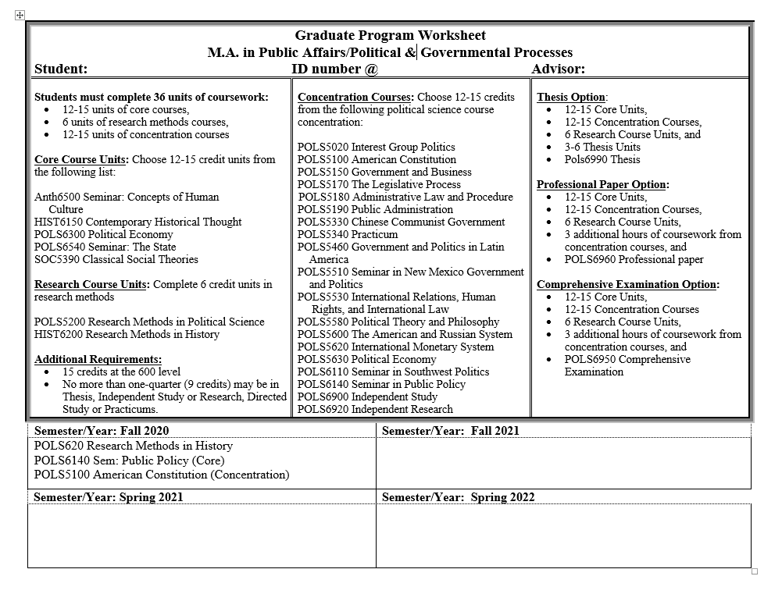

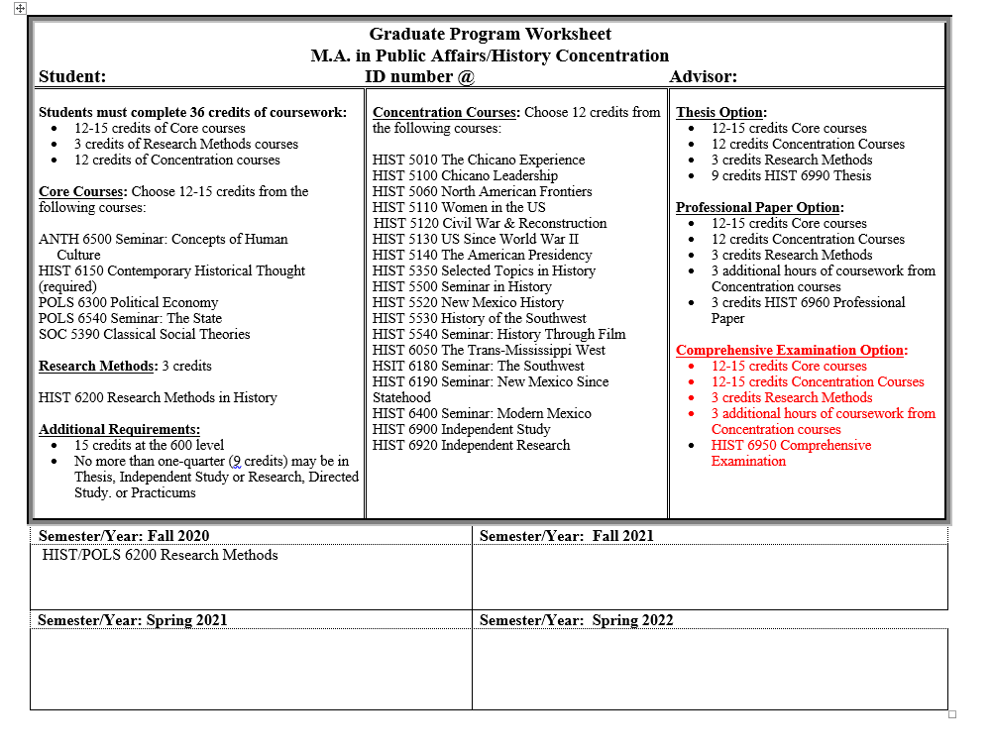
Please note that the Comprehensive Examination Option for the History Concentration has not yet been finalized by the Department or formally approved by the Academic Affairs Committee. Our expectation is that we will have things worked out sometime in the Spring 2022 semester.

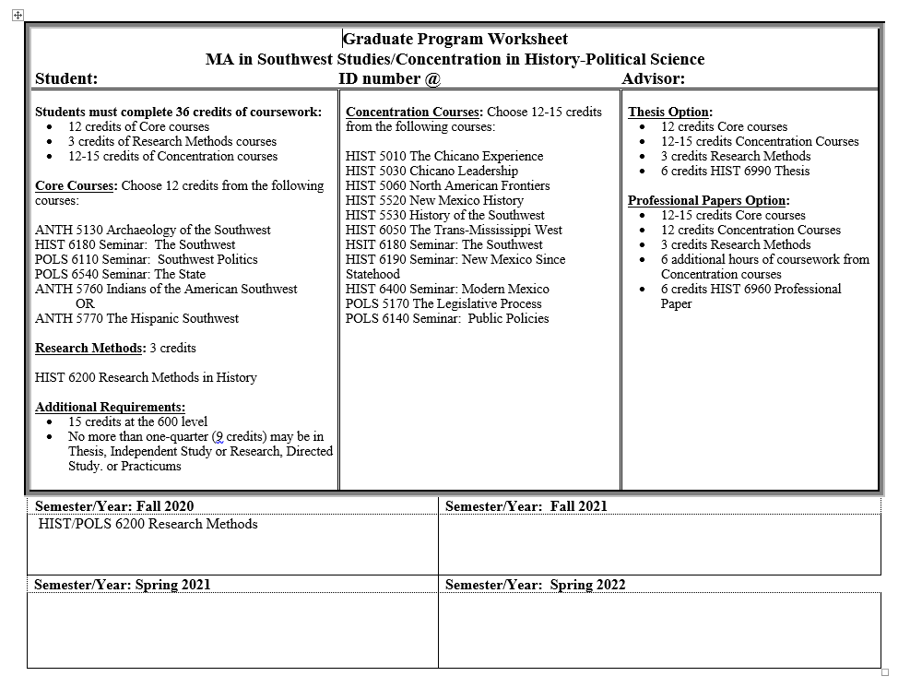

Appendix 3. Program of Study Forms

Public Affairs/Concentration in Political & Governmental Processes

Public Affairs/Concentration in History

Southwest Studies/Concentration in History & Political Science

NEW MEXICO HIGHLANDS UNIVERSITY
Graduate Program of Study
Department of History & Political Science
M.A. in Public Affairs/Concentration in Political & Governmental Processes

Instructions: (Please Type)
- This form must be either filled out electronically or typed. Forms that are handwritten will not be accepted.
- This form should be completed and signed upon the completion of all coursework.
- For questions about filling out the Program of Study, please speak to the Graduate Coordinator for History or your Academic Advisor in the Department.
- For details about the Program of Study, please see the latest edition of the Graduate Handbook.

Name____________________________________ ID Number @_____________________

Address____________________________________________________________________

E-mail_____________________________________ Phone Number___________________

Courses to be applied toward the degree:
Department Abbreviation, Course Number, & Title Semester Credits Grade
Required Core (12-15 Credits)
____________________________________________________________________________________________________________ ________________________________________________________________________________________________________________________________________________________________________________________________________________________________________________________________________________________________________________________________________________________________________________________________________________________________________________

Research Requirement (6 credits)
__________________________________________________________________________________________________
__________________________________________________________________________________________________

Concentration Requirements (12-15 Credits)
____________________________________________________________________________________________________________ ________________________________________________________________________________________________________________________________________________________________________________________________________________________________________________________________________________________________________________________________________________________________________________________________________________________________________________

Thesis/Professional Paper/Comprehensive Exam (9/6/3 Credits)
__________________________________________________________________________________________
__________________________________________________________________________________________
__________________________________________________________________________________________

Note that courses transferred from another institution require a Graduate Transfer of Credit Form to be attached to the Program of Study.

Total Credit Hours ________

________________________________________ ________________________________________
Student’s Signature Date Advisor’s Signature Date

________________________________________ _________________________________________
Department Chair’s Signature Date Dean’s Signature Date

________________________________________
Graduate Office Date

NEW MEXICO HIGHLANDS UNIVERSITY
Graduate Program of Study
Department of History & Political Science
M.A. in Public Affairs/Concentration in History

Instructions: (Please Type)
- This form must be either filled out electronically or typed. Forms that are handwritten will not be accepted.
- This form should be completed and signed upon the completion of all coursework.
- For questions about filling out the Program of Study, please speak to the Graduate Coordinator for History or your Academic Advisor in the Department.
- For details about the Program of Study, please see the latest edition of the Graduate Handbook.

Name____________________________________ ID Number @_____________________

Address____________________________________________________________________

E-mail_____________________________________ Phone Number___________________

Courses to be applied toward the degree:
Department Abbreviation, Course Number, & Title Semester Credits Grade
Required Core (12-15 Credits)
____________________________________________________________________________________________________________ ________________________________________________________________________________________________________________________________________________________________________________________________________________________________________________________________________________________________________________________________________________________________________________________________________________________________________________

Research Requirement (3 credits)
__________________________________________________________________________________________________

Concentration Requirements (12-15 Credits)
____________________________________________________________________________________________________________ ________________________________________________________________________________________________________________________________________________________________________________________________________________________________________________________________________________________________________________________________________________________________________________________________________________________________________________

Thesis/Professional Paper/Comprehensive Exam (9/6/3 Credits) __________________________________________________________________________________________________
__________________________________________________________________________________________________
__________________________________________________________________________________________________

Note that courses transferred from another institution require a Graduate Transfer of Credit Form to be attached to the Program of Study.

Total Credit Hours ________

________________________________________ ________________________________________
Student’s Signature Date Advisor’s Signature Date

________________________________________ _________________________________________
Department Chair’s Signature Date Dean’s Signature Date

________________________________________
Graduate Office Date

NEW MEXICO HIGHLANDS UNIVERSITY
Graduate Program of Study
Department of History & Political Science
M.A. in Southwest Studies/Concentration in History-Political Science

Instructions: (Please Type)
- This form must be either filled out electronically or typed. Forms that are handwritten will not be accepted.
- This form should be completed and signed upon the completion of all coursework.
- For questions about filling out the Program of Study, please speak to the Graduate Coordinator for History or your Academic Advisor in the Department.
- For details about the Program of Study, please see the latest edition of the Graduate Handbook.

Name____________________________________ ID Number @_____________________

Address____________________________________________________________________

E-mail_____________________________________ Phone Number___________________

Courses to be applied toward the degree:
Department Abbreviation, Course Number, & Title Semester Credits Grade
Required Core (12-15 Credits)
____________________________________________________________________________________________________________ ________________________________________________________________________________________________________________________________________________________________________________________________________________________________________________________________________________________________________________________________________________________________________________________________________________________________________________

Research Requirement (3 credits)
__________________________________________________________________________________________________

Concentration Requirements (12-15 Credits)
____________________________________________________________________________________________________________ ________________________________________________________________________________________________________________________________________________________________________________________________________________________________________________________________________________________________________________________________________________________________________________________________________________________________________________

Thesis/Professional Papers (9/6 Credits) __________________________________________________________________________________________________
__________________________________________________________________________________________________
__________________________________________________________________________________________________

Note that courses transferred from another institution require a Graduate Transfer of Credit Form to be attached to the Program of Study.

Total Credit Hours ________

________________________________________ ________________________________________
Student’s Signature Date Advisor’s Signature Date

________________________________________ _________________________________________
Department Chair’s Signature Date Dean’s Signature Date

________________________________________
Graduate Office Date

Appendix 4. Miscellaneous Graduate Program Forms

1.) Course Substitution Form
https://its.nmhu.edu/IntranetUploads/006955-GraduateCou-722020114844.pdf

2.) Change of Concentration Form
https://its.nmhu.edu/IntranetUploads/000365-GraduateCha-11172011113243.pdf

3.) Graduate Independent Study Instructions & Form
https://its.nmhu.edu/IntranetUploads/000595-Independent-621200745626.pdf

