Faculty Development Week: Library Overview

- How to use the library’s website
  - www.nmhu.edu/library

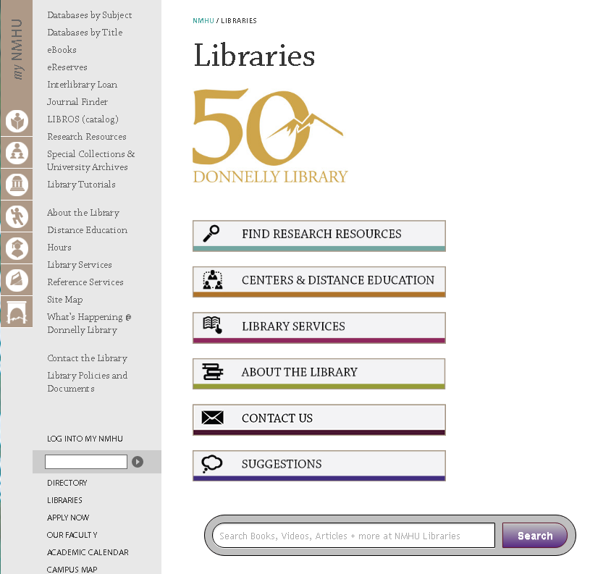

- How to check out books
  - Your NMHU Employee ID is your library card.
- How to access databases remotely
  - Your NMHU login will give you access.
  - You have to change your password from the temporary password first.
  - Some institutions have strict firewalls (schools, government agencies, hospitals). You may have to contact your IT department to get into our resources.
- How to request a library instruction session for your class
  - Contact Leslie Broughton at 505-454-3408 or labroughton@nmhu.edu.
- How to put material on reserve for a class
  - Contact Raymond Chavez at 505-454-3403, chavez_ray@nmhu.edu or April Kent at 505-454-3139, ajkent@nmhu.edu. For Albuquerque Center reserve requests, contact Helen Robertson at 232-6000, hsrobertson@nmhu.edu.
  - Both e-reserves and physical reserves are available.
- How to use the Interlibrary Loan Service
  - Set up an account from the library website, or
  - Come to the library’s main desk for assistance.
- Please encourage your students to take the Library Research Class – Advanced and Basic available—see flyers.
- Contact us if you have any questions.
  - See other side of this handout for all librarians’ contact information.

