Introduction to Library Services & Collections
Available Online

The Highlands University Libraries’ webpage provides online access to e-books, electronic journals, and academic databases. In addition, the webpage is your portal to library services such as electronic course reserves, Interlibrary Loan, and reference assistance.
To access the Libraries’ webpage, click on the Libraries link at the bottom of the university’s homepage http://www.nmhu.edu/
or go directly to http://www.nmhu.edu/library.

To access some library resources from off-campus, you will need to enter your NMHU username (just the first part of your e-mail address) and password. For help finding your user name and password go to http://its.nmhu.edu/help/.

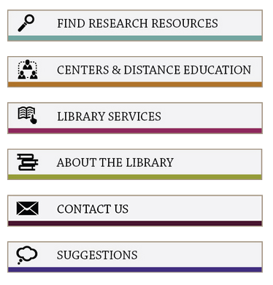
Collections available online
Catalog of library materials (LIBROS)
Academic Databases in a wide variety of subject areas
Electronic Journals -- over 48,000 titles
Electronic Books -- over 102,900 titles

Services available
eReserves gives you 24/7 electronic access to course material put on reserve by instructors.
Interlibrary Loan allows you to electronically request and receive journal articles not available through Highlands University Libraries.
Reference and Research Assistance is provided by library staff by email, chat, phone, and in person.
Library Passports will allow you to check out books from other New Mexico Academic Libraries. You can request a passport online.

Questions? Need Help?
Email us @ libinfo@nmhu.edu
Call us @ 505.454.3401 (Toll Free: 1.877.850.9064 x3401)

More Library Guides and Tutorials are available at http://www.nmhu.edu/libraryvenues/hlibrary/Services/tutorials.aspx

Frequently Asked Questions Page:
http://www.nmhu.edu/library/library-faqs/

