How to Request a Book
Search for the book on the library’s home page, you may have to scroll down to see the search box.
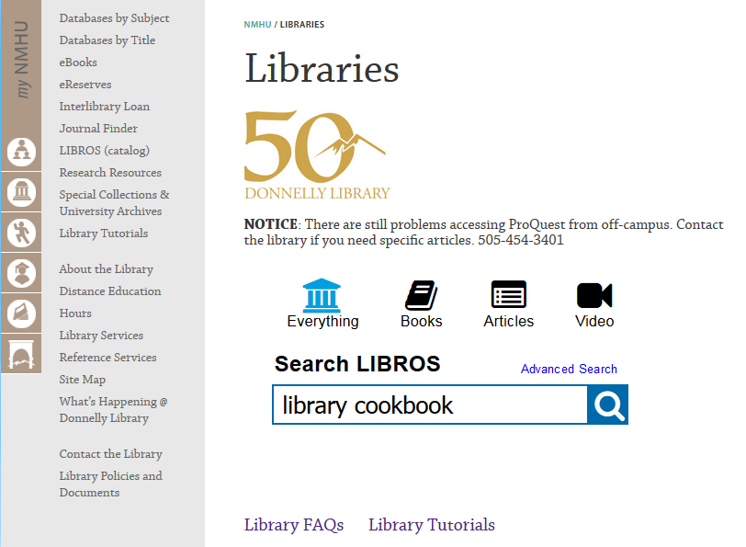

Click on the Place hold button once you locate the item
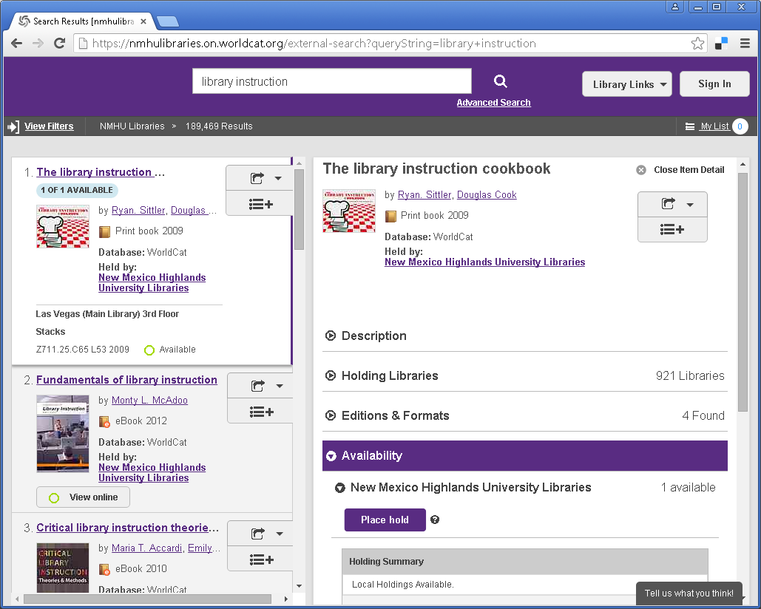
Log in with your banner @ number when prompted. You will need to create a password for your LIBROS account if you haven’t done so. Click on Set/reset password link.
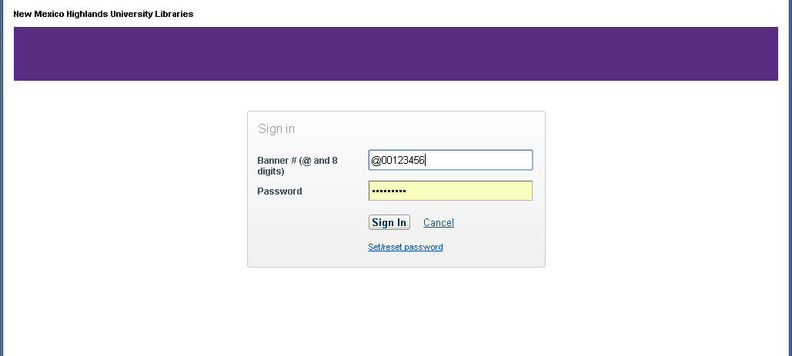
Select the correct pick up location. The default is Las Vegas (Main Library) and then click Submit.

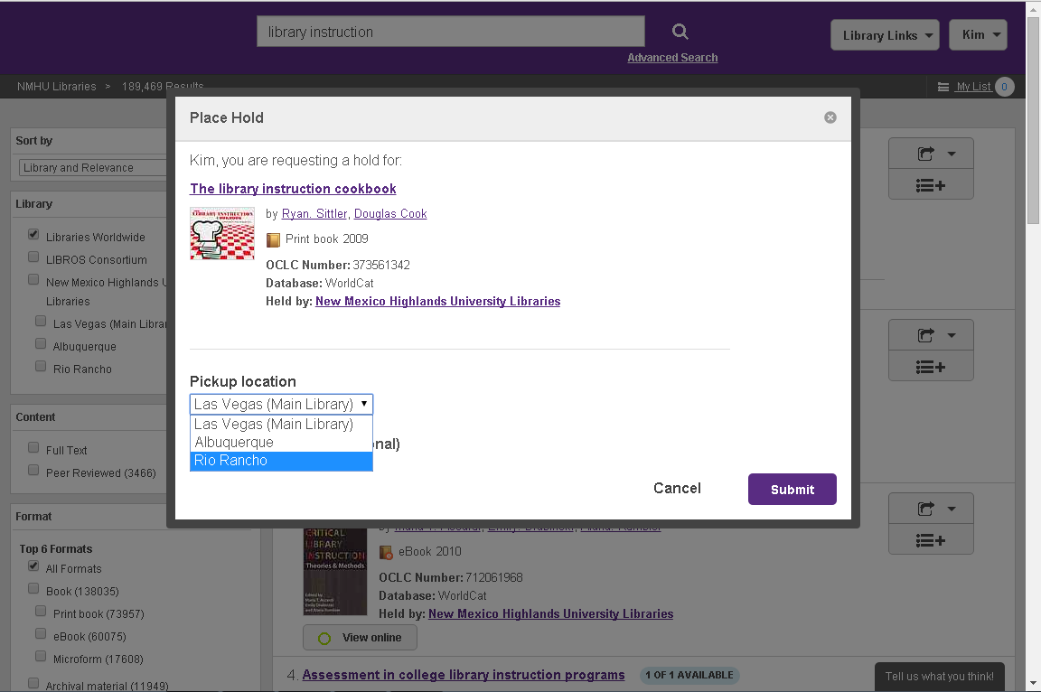

You should see a confirmation screen if your hold was correctly placed.
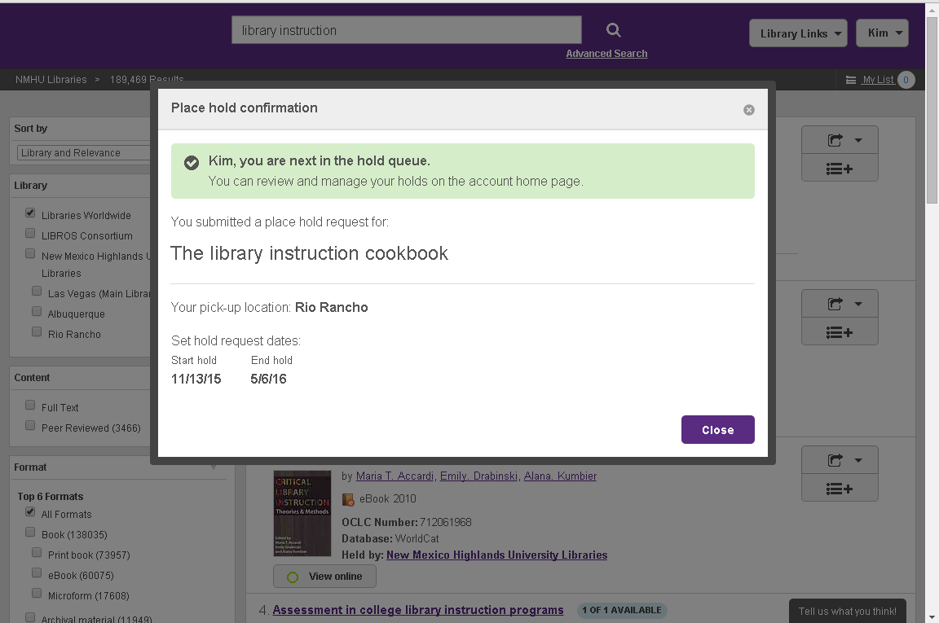
You can view your holds by clicking your name in the top right corner, click on My Account, then Holds.
